PHASE 2
Design Document

Dio’s Treasure


Developed by Mwilu Siakachoma

Signoffs
Phase | Teacher | Date | Signature
2) Design Document | Mrs Rajamany

1. Summary

- Main Page

This will be the main page when the user opens the applications. It will welcome the user and have two buttons which will allow the user to either create an account or to login. There will be a button to exit the application.

- Label: Welcoming the user to the game

- Button 1: Sign In
This will take them to the ‘Login’ page to enter the existing credentials (password and username) and enter personalized account.

- Button 2: Sign Up
This will take the user to the ‘Sign Up’ page to enter their personal account that will create an account for them to use on a regular basis and have their game progress saved.

- Button 3: “X” (to exit)
This will close the application.

- Create Account

This will ask for the user’s information to create an account. There will be a back button that will take them to the main page. I will use my data validation task to create these accounts.

- Label 1: “Sign Up Now!”

- Label 2: name

- Label 3: surname

- Label 4: grade

- Label 5: date of birth

- Text field 1: name
This will be used for the user to input their first name, using the keyboard.

- Text field 2: surname
This will be used for the user to input their second name, using the keyboard.

- Combo Box: grade (5, 6, 7, 8)
This will be used for the user to select their grade from 5 to 8. They will use their mouse to select it.

- JDateTimeChooser: date of birth
The user will select their date of birth with their mouse.

- Button: Sign Up
This will create the account for the user and thereafter take the user to the ‘User Info’ page.

- Button 2: back (to go to main page)
This will take the user back to the ‘Main page’

- New User Info Page

This page will welcome the new users and show them their username and password. A continue button will be their to take the user to the main menu.

- Label 1: “Welcome, ”

- Label 2: username

- Label 3: password

- Label 4: actual username
This will be retrieved from the database table with all the users pertaining their login details.

- Label 5: actual password
This will be retrieved from the database table with all the users pertaining their login details.

- Lable 6: take a screenshot

- Button 1: screenshot button
This button will capture the screen of the user’s computer and save the image in the user’s files.

- Main Menu

This will consist of three buttons which the user can either pick the level that they desire to play, go to their profile or logout which will make the user go back to the main page.

- Button 1: Play
This will take the user to the Level Menu where they will pick between the three different levels the game has – multiplication, addition and subtraction.

- Button 2: Options
This will take the user to the Game Options page where the user can change the volume settings of the application as well as visit their profile.

- Button 3: Quit
This will sign the user out of their personal account and exit the application.

- Level Menu
This page is used for the user to pick which level they would like to play. It will consist of three buttons (each level – Addition, Subtraction and Multiplication) and the user will be able to return to the main menu by pressing the escape button.

- Label 1: “Press ‘Escape’ to return to the main menu”

- Button 1: Addition level
This will begin the game level “Addition” and will provide the game screen to the user.

- Button 2: Subtraction level
This will begin the game level “Subtraction” and will provide the game screen to the user.

- Button 3: Multiplication level
This will begin the level “Multiplication” and will provide the game screen to the user.

- Game Options
This will allow the user to change the settings of the sound effects as well as the music. The user will be able to mute the music and/or the sound effects and/or change the volume of the sound in the program. The user will also have a menu button that will take them back to the main menu and a profile button to allow them to see their scores as well as personal information.

- Button 1: Music
This button will allow the user to mute or unmute the music in the program.

- Button 2: Sound Effects
This button will allow the user to mute or unmute the sound effects in the game.

- Volume Button:
The volume button will be used by the user, to determine the level of volume of the music and sound effects in the program.

- Volume Slider:
The slider indicates how much volume the sound effects and music are being provided with in the program.

- Button 4: Main Menu
This button will allow the user to return to the main menu of the program.

- Button 5: Profile
This button will allow the user to go to their profile page and see their personal information (name, surname, grade and date of birth) as well as the overall high scores and their own high scores for each level.

- Login

This will prompt the user to put in their login details (username and password) with a button that allows for the user to enter their account. There will be a back button to take the user back to the main page.

- Label 1: Username

- Label 2: Password

- Text Field 1: Username
The user will input, via keyboard, their username they were given upon creating their personal account.

- Text Field 2: Password
The user will input, via keyboard, their password they were given upon creating their personal account.

- Button 1: Sign In
This will verify whether the user’s account exists and take them to the main menu if the login is successful.

- Profile

This will show the user’s personal information, high score ranking and the top 10 ranking. There will be a back button to take the user back to the main menu.

- Label 1: Name

- Label 2: Actual name of user
This will be retrieved from the database table containing all the user’s personal information upon signing up. It will display the name of the user.

- Label 3: Surname

- Label 4: Actual surname of user
This will be retrieved from the database table containing all the user’s personal information upon signing up. It will display the surname of the user.

- Label 5: Grade

- Label 6: Actual grade of user
This will be retrieved from the database table containing all the user’s personal information upon signing up. It will display the grade of the user.

- Label 7: Date of birth

- Label 8: Actual date of birth of user
- This will be retrieved from the database table containing all the user’s personal information upon signing up. It will display the date of birth of the user.

- Label 9: My High Scores

- Label 10: Overall High Scores

- Combo box 1: Levels
This combo box will allow the user to select which top 5 users are the highest scoring of a certain level. They will choose one of the 5 levels and the JTables will show the information based on what level the user has picked.

- JTable 1: User High scores
This will show the top 5 highest scores of the user for each level based on the selection of the combo box.

- JTable 2: Overall High Scores
This will show the top 5 highest scoring users of each level based on the selection of the combo box.

- Button 1: Back button
This button will take the user back to the main menu of the application.

- Game

The platform math game. The controls will consist of the four arrow keys and the space bar. The game will have a menu where the user can exit the game and go back to the main menu as well as replaying the game.

2. Interface Design GUI screens

These separate interface elements / environments are described in detail below:

a) GUI screen: ≪Welcome Page≫
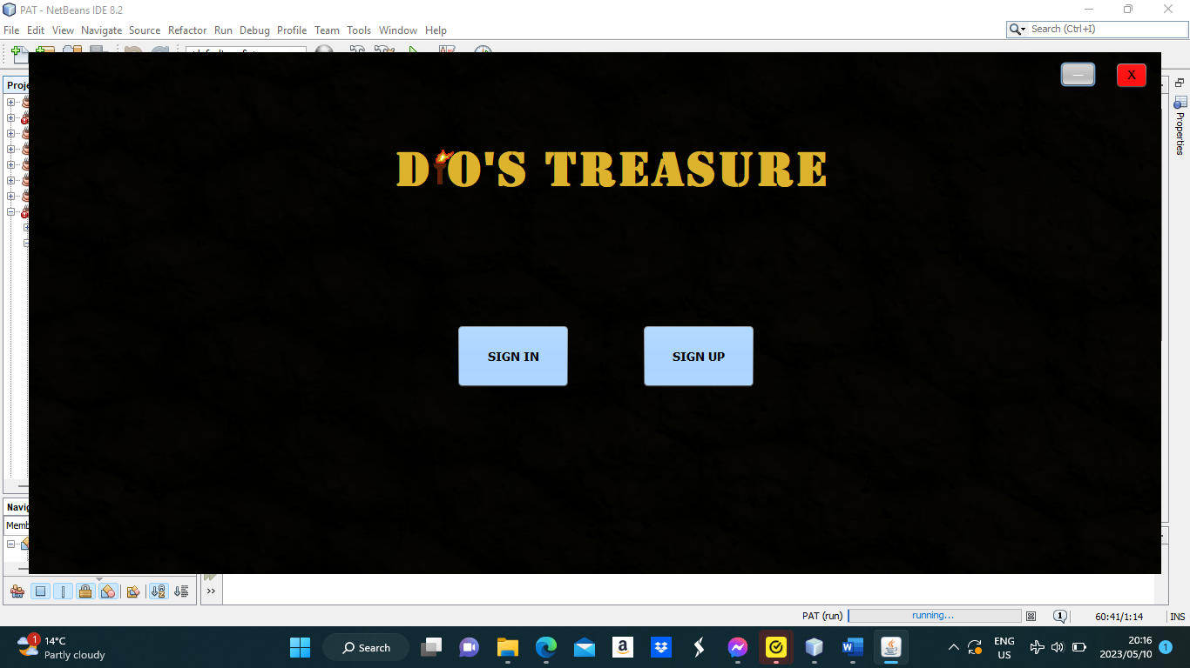

Description | This will be the first screen the user views when they start the application.  This will welcome the user and have two buttons that will give the user the option to SIGN IN (into their account that they have made) or SIGN UP (to create an account for the use of the game).
Security Group | All users can see this page.
Data | - SIGN UP (Button)  - SIGN IN (Button)  - MINIMIZE (Button)  - “X” – Exit (Button)  Only these components are used for this page. The user will not input any information on this page.
Actions | - SIGN UP (Button): It will take them to the SIGN UP PAGE  - SIGN IN (Button): It will take them to the SIGN IN PAGE  - MINIMIZE (Button): It will minimize the application and will hide the application screen completely, until it is clicked on again.  - ‘X’ – exit (Button): The user will close the application

GUI screen: ≪Sign Up page≫

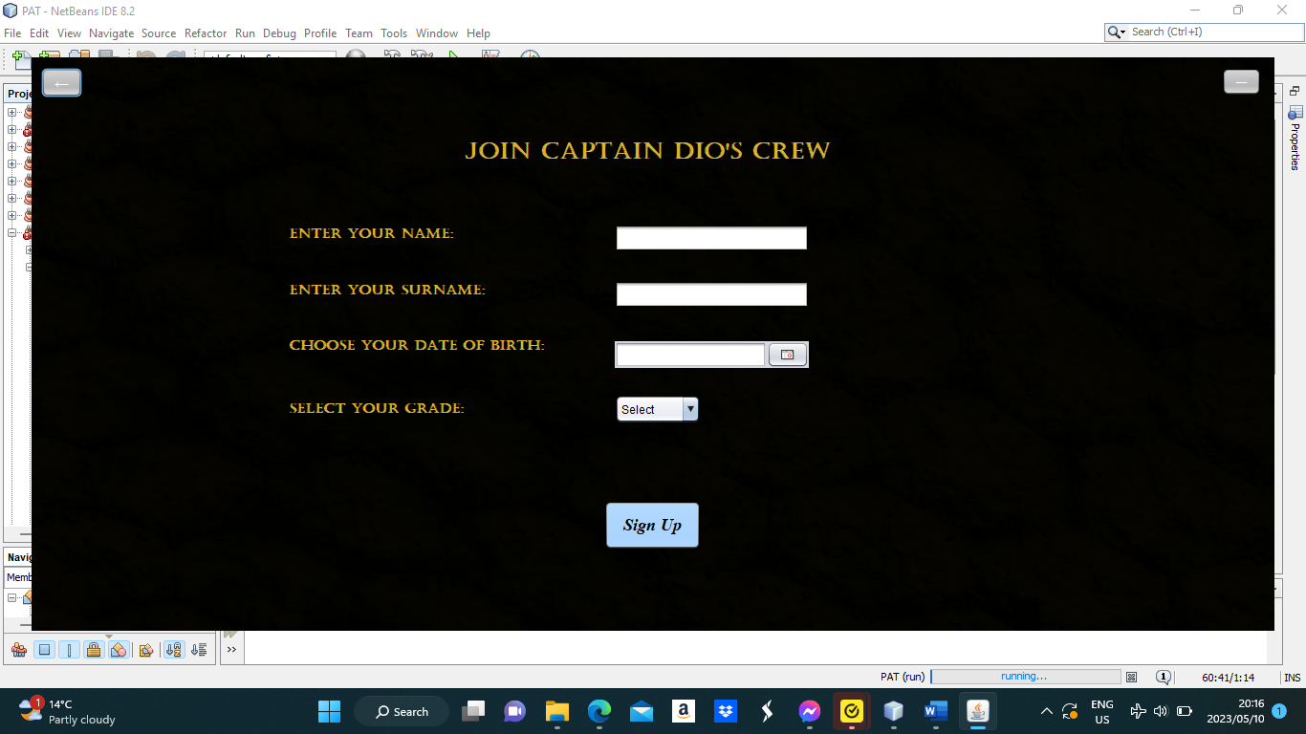

Description | This will be the screen that the user will see if they click on the “SIGN UP” button. This will enable the user to input their personal information and create an account.
Security Group | All users can see this page.
Data | - Name (Text Field): Will be stored in database table tblUserInfo  - Surname (Text Field): Will be stored in database table tblUserInfo  - Grade (Combo box): Will be stored in database table tblUserInfo  - Date of birth (JDateChooser): Will be stored in database table tblUserInfo  - Name (Text Field): Input user’s name.  - Surname (Text Field): Input user’s surname.  - Grade (Combo box): User selects grade from combo box by clicking on the grade.  - Date of birth (JDateChooser): User selects their date of birth from the calendar icon.
Actions | - Sign Up (Button): When clicked, the user will be taken to the NEW USER INFO page IF all the information is correctly inputted AND the information is not the same as an existing record in the table. Error messages will be displayed if any information is not inputted correctly or if the user is trying to create an account with identical data they have already used.  - MINIMISE (Button): It will minimize the application and will hide the application screen completely, until it is clicked on again.  - Back (Button): (In the top left corner) When clicked, it will take the user to the main page.

GUI screen: ≪New User Info page ≫

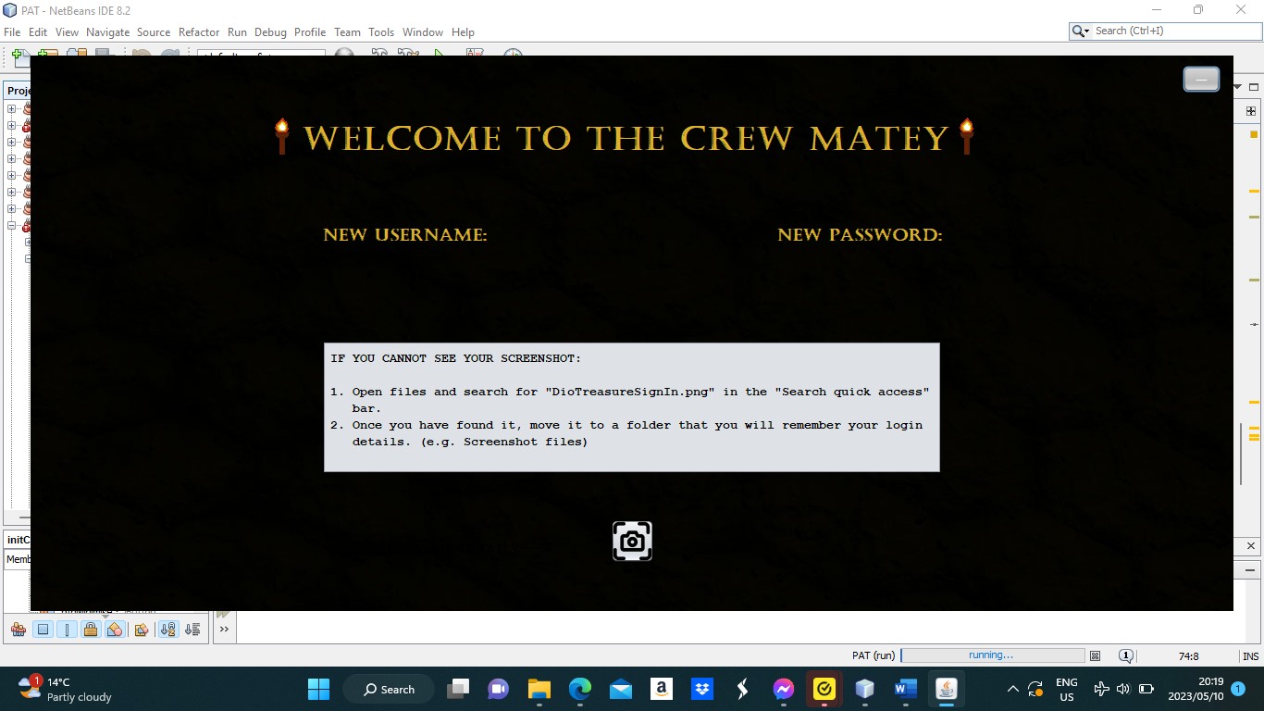

Description | After the user has successfully created an account, the user will be shown their new username and password – that is stored in tblUsers for users’ login details -- for logging in and a button to take a screenshot of these credentials.
Security Group | All users who have created an account can see this page.
Data | - Username (label): The information of the user’s new username will come from the database table “tblUsers”  - Password (label): The information of the user’s new password will come from the database table “tblUsers”
Actions | - Screenshot (button): Takes a screenshot of the user’s screen and saves it in Files. A file name is generated and the user can search for the image as “DioTreasureSignIn.png”.  - MINIMIZE (Button): It will minimize the application and will hide the application screen completely, until it is clicked on again.

GUI screen: ≪Sign In page≫
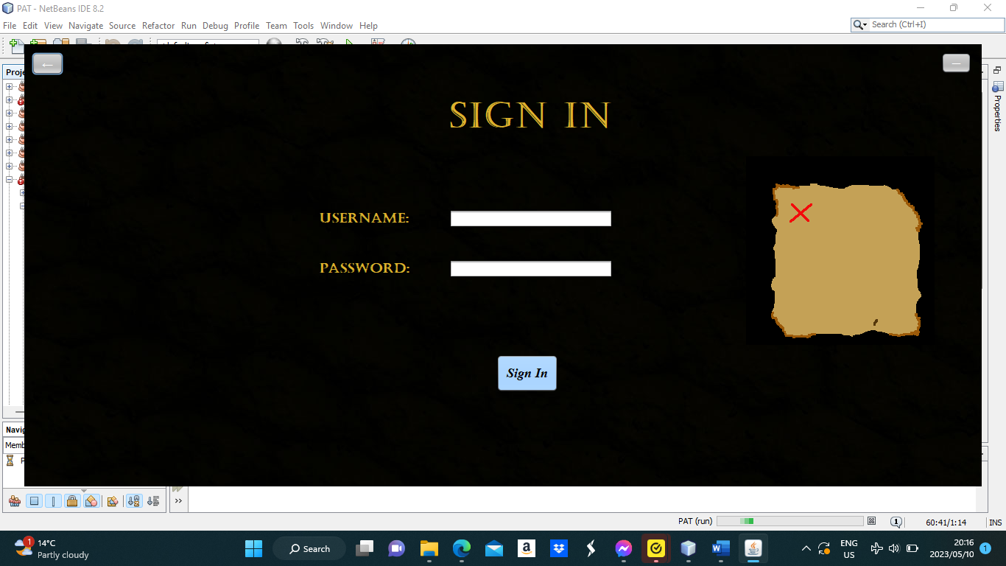

Description | If the user already has an account they have created, then they will be able to sign into that account and have access to all their progress they have made in the game.
Security Group | All users can see this page.
Data | - Username (Text Field): IF the user has already created an account, the user will enter their username which will be retrieved from database table tblUser  - Password (Text Field): IF the user has already created an account, the user will enter their password which will be retrieved from database table tblUser
Actions | - Sign In (button): If it is clicked then it will check if the information is valid from the data in the database table (tblUser) and will take them to the MAIN MENU. An error message will be displayed if the login details are incorrect and do not match or if the login credentials do not exist in the database table, tblUsers.

GUI screen: ≪Main Menu≫

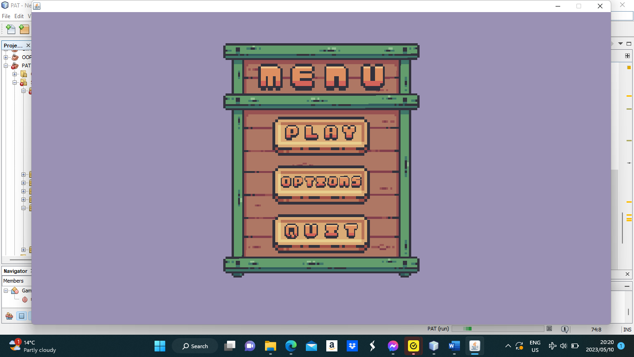

Description | This is the screen that will be seen after the user has signed in or after the user has taken a screenshot of their user information, after signing up. This screen consists of the game options, playing the game(which will ask you to pick a level beforehand) and exiting the game.
Security Group | Users who have signed in/created an account will be able to see this page.
Data | - Options (button)  - Play (button)  - Quit (button)  Only these components are used for this page. The user will not input any information on this page.
Actions | - Options (button): This will allow the user to go to the PROFILE page to see all their user information. They will be able to see their personal information as well as the top 5 highest scoring users in each level.  - Play (button): This will load a new game or the latest save of the user, based on whether they have played or not and saved their progress or not.  - Quit (button): This will log the user out of their account and exit the application.

GUI screen: ≪Profile≫

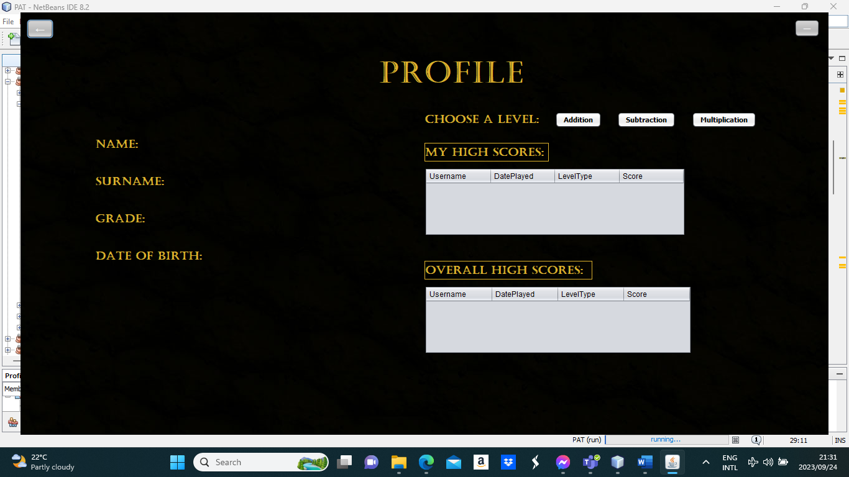

Description | This page will show the information of the user that they used to sign up. This will also show the user their password and username. There will be an option to go back to the main menu too.
Security Group | Users who have signed in/created an account will be able to see this page.
Data | - Name (label): This will be displayed from tblUserInfo.  - Surname (label): This will be displayed from tblUserInfo.  - Grade (label): This will be displayed from tblUserInfo.  - Ranking – Top 5 of the Users’ scores (JTable): This will be displayed from tblScores and will be determined by a query to show the top 5 scores, of the user, in the level selected from the combo box.  - Ranking – Top 5 of scores overall (JTable): This will be displayed from tblScores and will be determined by a query to show the top 5 scores, overall in the game, in the level selected from the combo box.
Actions | - Back (button): When this is clicked, it will take the user back to the main menu.  - MINIMIZE (Button): It will minimize the application and will hide the application screen completely, until it is clicked on again.  - Button (Addition): This will display the users’top 5 highest scores of this level as well as the top 5 overall highest scores of this level.  - Button (Subtraction): This will display the users’top 5 highest scores of this level as well as the top 5 overall highest scores of this level.  - Button (Multiplication): This will display the users’top 5 highest scores of this level as well as the top 5 overall highest scores of this level.

GUI screen: ≪Level Menu≫

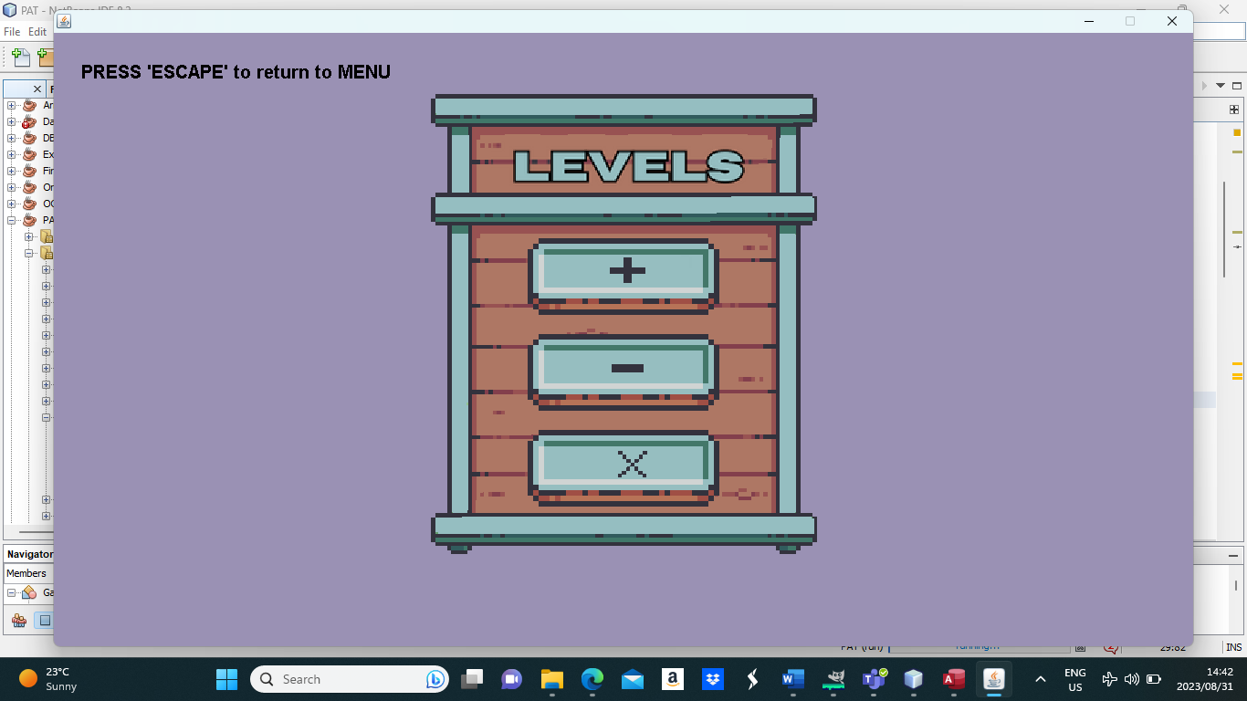

Description | This page will allow the user to select a level to play.
Security Group | Users who have signed in/created an account will be able to see this page.
Data | - Addition (button)  - Subtraction (button)  - Multiplication (button)  Only these components are used for this page. The user will not input any information on this page apart from pressing ‘escape’ to return to the main menu.
Actions | - Addition (button): This will allow the user to play the addition level where the game will only ask the user about sum questions.  - Subtraction (button): This will allow the user to play the subtraction level where the game will only ask the user about difference questions.  - Multiplication (button): This will allow the user to play the multiplication level where the game will only ask the user about product questions.

GUI screen: ≪Game Options≫

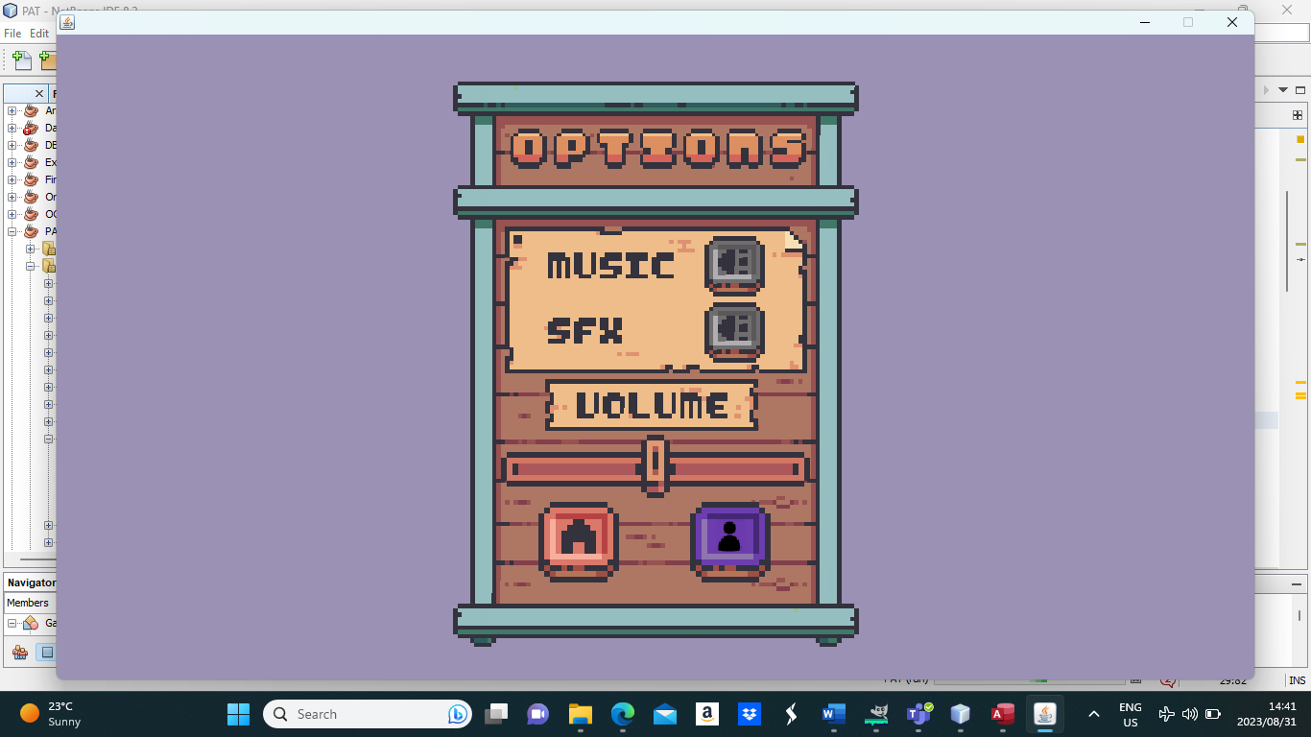

Description | This page will allow the user to change the sound settings of the game. The user can opt to mute or unmute the sound effects and/or music in the program as well as change the volume of the sound. They will also be given the option to return to the main menu via the menu button or go to their profile to see their top 5 highest scores for levels and the overall highest scores for levels.
Security Group | Users who have signed in/created an account will be able to see this page.
Data | - Mute/Unmute (buttons)  - Volume Button (button)  - Volume Slider (slider)  - Menu (button)  - Profile (button)  Only these components are used for this page. The user will not input any information on this page.
Actions | - Mute/Unmute (buttons): These buttons will be used to mute or unmute the sound effects and/or music in the program and game.  - Volume Button (button): This button will be slid across the volume slider to determine the amount of volume that will be provided for the sound effects and music in the program and game.  - Menu (button): This will return the user to the main menu of the program where the user can play and select a level or quit and log out of their account.  - Profile (button): This will take the user to their profile page where they can see their personal information as well as their high scores for all levels and the overall high scores in the game for each level.

GUI screen: ≪Game≫

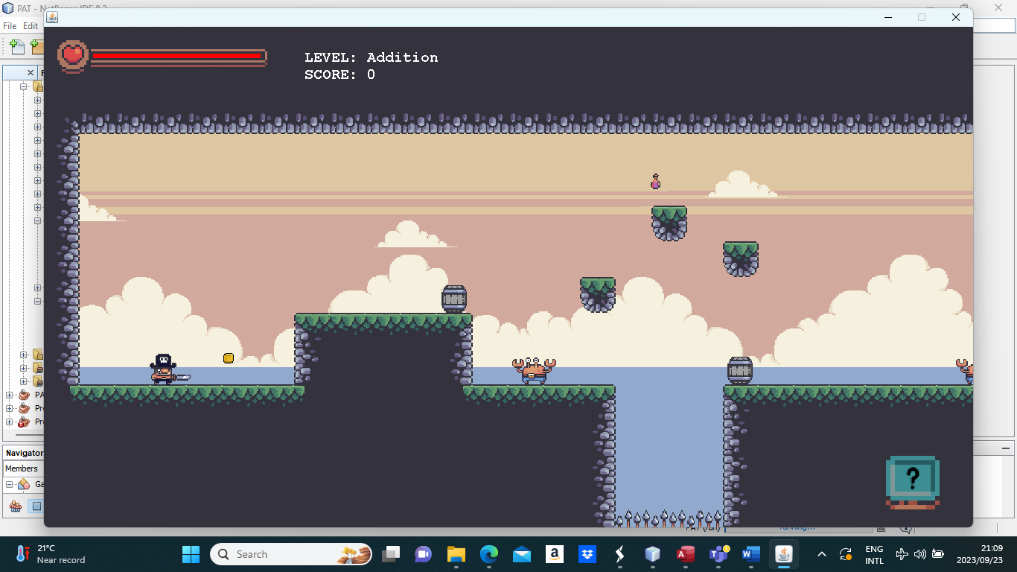

Description | This is where the user will play the actual game. This will have the background and the platforms for the game as well as the character, the health bar of the player and the help button. Each level will look a little bit different from the others but will consist of the same game objects, health bar and help button.  The game over, pause menu and help buttons will only appear when the user interacts with the help button or presses specific keys to see those overlays appear. (The specific keys to press can be found in the help overlay – which will be displayed after pressing the help button)
Security Group | Users who have signed in/created an account will be able to see this page.
Data | - Answers (JOptionPane): This will be entered by the user and will determine the score of the user.  The question will only appear when the user makes contact with the coin object in the game.  - Score (drawString) : This will show the score obtained by the user. (This will update as the user answers questions correctly or incorrectly)  - Level (drawString) : This will show the type of level being played.
Actions | - Pause menu (button): When the user clicks ‘Enter’, the pause menu will come up with the following options:  - Resume (button): When the user clicks on this, the user will continue playing the game.  - Home (button): When the user clicks on this, the user will be taken back to the MAIN MENU.  - Save (button): When the user clicks on this, the user will save their progress on which level they are on.  - Volume control (slider): This will control the volume of the sounds in the game, from the loudest to mute.  - Character  .  - Moving character (KeyListener): When the user uses the left and right arrows then the character will move in those directions.  - Jumping character (KeyListener): When the user uses the space bar, then the character will jump.  - Attacking character (KeyListener): When the user uses the key character ‘s’ then the character will attack.  - Help Button: It will show the user all the instructions of how to play the game and what each objects means as well as what keys to press and how to navigate the game.

3. Program Flow Sequencing

- <Welcome Page displayed> – Welcomes the user and has options to…
- Close the application.
- Sign into their account.
- Or to create a new account.

- If the user clicks sign in…
- The user will enter their username.
- The user will enter their password.
- They will click the sign in button to determine whether the account exists or not. If the account does exist then they will be taken to the main menu of the game, otherwise an error message will be displayed to tell the user that the account does not exist.
- If the user clicks the back button, then they will be taken back to the welcome page.

- If the user clicks on sign up…
- The user will enter their personal information into the spaces provided (Name, surname, grade, date of birth).
- If the information fulfils all criteria and the user has not tried to create another account using identical existing data for a previously made account then…
- The user will then be taken to the New User Info Page to…
- Take a screenshot of their new username and password. After taking a screenshot they will be taken to the main menu.

- Once the user has done one of the options (login or taken a screenshot of their login details), they will be taken to the main menu where they either…
- Play the game and pick a level to play.
- Quit and exit the application.
- Or go to the game options page.

- If the user clicks on Play…
- The user will be taken to the level menu page to pick one of the 3 levels available in the game (multiplication, addition and subtraction).
- If the user wishes to return to the main menu, they must click ‘escape’.
- After selecting a level, the user will be taken to that levels particular game screen and the user will be able to play the game.
Furthermore, while the user is playing…
- If the user wants to pause…
- A pause menu with the following buttons…
- Replay button will allow the user to start the game again.
- Unpause button will allow the user to carry on with their progress of the game.
- The home button will allow the user to go to the main menu of the application.
- Music button to mute the music of the game or turn it on.
- The sound effects button will allow the user to mute the sound effects of the game or turn it on.
- The volume rocker will allow to change the loudness of the sound within the application.

- If the user clicks the help button…
- Two images containing the controls of the game as well as how to play the game will appear.
- If the player wishes to continue playing, they must press ‘escape’.

Furthermore, while the user is playing…
- When the user is playing the game…
- They will interact with a coin which will make the user answer a math problem, based on the level selected.
- Once they have answered a math problem, it will be added to their points – based on whether it is correctly answered.
- They will then kill enemies while trying to get other coins to answer more questions. Questions will regenerate when all barrels and boxes, as well as any coins, are not present in the game anymore. Enemies will regenerate when the player has killed all of them.

- If the user clicks on Options…
- They will be taken to the game options screen where they will see…
- Buttons to mute/unmute the sound effects and/or music for the program and game.
- A volume button with a slider that dictates the volume of the music and sound effects in the program.
- A menu button to return to the main menu of the program.
- A profile button. If the profile button is clicked…

- The user will be taken to the profile page where they will be able to see…
- Their personal information they used to create their account.
- Their top 5 high scores for a particular level they choose with the combo box.
- The top 5 highest scores in the game for each level based on which level is selected with the combo box.
- A combo box for the user to select which level they would like to see their own personal highest scores as well as the overall highest scores, based on the level they choose.
- A back button will be provided for the user to return to the game options page.

- If the user clicks on Quit…
- The user will exit the application.

4. Class design Objects / Classes to be developed

Class Name: User
Purpose of class: The class adds the information from the sign-up page into the database table tblUserInfo and creates the users’ usernames and passwords and adds them to tblUser.
Fields
Field Name | Data type | Description
- name | string | Stores the details of the user’s name
- surname | string | Stores the details of the user’s surname
- grade | integer | Stores the details of the user’s grade
- DOB | date | Stores the details of the user’s date of birth
Methods
Method name | Data type (if typed) / void | Description – what it accepts, sets and returns
+ User(string n, string s, integer g, date d) | Constructor | It accepts the parameters of a name, surname, grade and date and sets those variables to whatever the values are. It also instantiates a ‘User’ object.
+insertUserInfoRS() | void | It accepts no parameters and enters the data of the User object into tblUserInfo.
+insertLoginDetailsRS() | void | It accepts no parameters and enters the data of the username and password, created from the values from User object, and inserts them into tblUser.
+createPassword() | String | It accepts no parameters and uses the information of the user to create a new password for the user.
_{+createUsername()} | String | It accepts no parameters and uses the information of the user to create a new username for the user.
Class Name: Connector
Purpose of class: Connects my java application to my database “Dio Treasure”.
Fields
Field Name | Data type | Description
- conn | Connection | Used to connect the database to the java program.
- stmt | Statement | Used for queries that are needed for query manipulation.
Methods
Method name | Data type (if typed) / void | Description – what it accepts, sets and returns
+ Connector (String dbName) | Constructor | This will connect the program to the database. It accepts a string which is the name of the database.
+executeQuery(String qry) | ResultSet | This is used for queries I may want to use displaying elements from database tables as well as sorting, ordering, etc. It accepts a string which is the query that will be performed.
+executeUpdate(String qry) | void | This is used for update, insertion and deletion queries as they make changes to the tables. It accepts a string which is the query. It accepts a string parameter for the query that will be performed.

Class Name: BackEnd
Purpose of class: This class is used to deal with all the back-end content regarding the user by showing any information that will be required for the user and for determining users that are currently signed in.
Fields
Field Name | Data type | Description
- userArr | User [] | This will store all the personal information of all users from tblUserInfo.
- count = 0 | integer | This will keep track of how many items are in the array.
- db | Connector | This is used to perform the query that will be needed in order to populate the array.
Methods
Method name | Data type (if typed) / void | Description – what it accepts, sets and returns
+newUserLogin() | String | This retrieves the login details of the latest user to create an account from tblUsers. This will be used to display them so that the user can take a screenshot of their new details. There are no parameters.
+loginArray() | void | This stores all the login details from tblUsers and will later be used to validate user entry as well as the userID of an user. There are no parameters.
+checkLogin(u : String, p : String) | Boolean | This is used to check whether the user has entered the correct login credentials to further gain access to the program. It accepts string parameters of the username and password that will be retrieved from the GUI to check if it matches with any items in the login array.
profileInfo() | String | This returns the user that is currently logged into the application to show their personal information in the profile page. There are no parameters.
+profileLbls(lbl1 : JLabel, lbl2 : JLabel, lbl3 : JLabel, lbl4 : JLabel) | Void | This is used to set the labels in the profile page with the currently logged in user’s personal information. It accepts the parameters of the labels that will display the user’s information.
setOnlineUser(user:String) | void | This gets the user that is currently logged in and stores it in a text file. It accepts a string parameter of the user that has logged in.
+getOnlineUser() | String | This retrieves the user that is currently logged in from the text file and returns the data as a string. There are no parameters.
+getUserID() | Integer | This retrieves the userID of the user that is currently logged in by trying to found what number item the user is stored in and returns an integer. There are no parameters.

Class Name: UserArray
Purpose of class: This class is used to create an array of all the personal information of users. It will determine whether a user is trying to create an account using identical information that was used to create an account previously.
Fields
Field Name | Data type | Description
- loginArr | String [] | Used to store all the login details in tblUsers.
- count = 0 | int | Used to count how many items are in the array.
- db | Connector | This is used to perform the query that will be needed in order to populate the array as well as checking for the currently logged in user and for displaying user information from the database tables.
Methods
Method name | Data type (if typed) / void | Description – what it accepts, sets and returns
+UserArray() | Constructor | It will read all the records from tblUserInfo into the array.
+existingUser(name:String, surname:String, grade:integer, dob:Date) | boolean | This checks to see if the user is not trying to create an account with identical information that was used to make a previous account. It accepts the parameters of the name, surname, grade and date of birth that is entered by the user in the sign up page.

Class Name: DataValidation
Purpose of class: This class is used to provide validation that is input by the user in the sign in and sign up pages to make sure that data is correct to proceed further into the program and for no errors will occur.
Fields
Field Name | Data type | Description
- name | String | The name of the user.
- surname | String | The surname of the user.
- grade | Integer | The grade of the user.
- dob | Date | The date of birth of the user.
Methods
Method name | Data type (if typed) / void | Description – what it accepts, sets and returns
+DataValidation() | Constructor | Instantiates a data validation object.
+presenceCheckName(txtName:JTextField, lblNameError: JLabel) | Boolean | This checks whether the user has entered anything into the text field for the name. If not, the label will display an error message telling the user to enter something.
+typeCheckName(txtName:JTextField, lblNameError: JLabel) | Boolean | This checks to see if the user has entered characters that are letters instead of any other abnormal characters that are not found in a name. An appropriate message will be displayed through the error label.
+lengthCheckName(txtName:JTextField, lblNameError: JLabel) | Boolean | This checks that the user has inputted a name that is longer than 2 characters. If not, an error message will be displayed in the label.
+presenceCheckSurname(txtSurname:JTextField, lblSurnameError: JLabel) | Boolean | This checks whether the user has entered anything into the text field for the surname. If not, the label will display an error message telling the user to enter something.
+typeCheckSurname(txtSurname:JTextField, lblSurnameError: JLabel) | Boolean | This checks to see if the user has entered characters that are letters instead of any other abnormal characters that are not found in a name. An appropriate message will be displayed through the error label.
+lengthCheckSurname(txtSurname:JTextField, lblSurnameError: JLabel) | Boolean | This checks that the user has inputted a surname that is longer than 2 characters. If not, an error message will be displayed in the label.
+presenceCheckGrade(cmbGrade:JComboBox,lblGradeError: JLabel) | Boolean | This checks whether the user has selected a grade. If not, an appropriate error message will be displayed.
+checkDOB(lblDOBError: JLabel, dtcDOB: JDateTimeChooser) | boolean | This checks to see if the user has chosen a date of birth and whether it corresponds to the grade chosen. Appropriate error messages will be displayed where necessary.
+getSurname() | String | This accessor method returns the surname of the user.
+getName() | String | This accessor method returns the name of the user.
+getGrade() | Integer | This accessor method returns the grade of the user.
+getDob() | LocalDate | This accessor method returns the date of birth for the user.
+existingUserLbl() | String | This returns a string with an error message for any existing users, if a user tries to create an account with identical existing data.
+validate(lbl1:JLabel, lbl2:JLabel, lbl3: JLabel, lbl4: JLabel, lbl5:JLabel) | boolean | This validates whether all the information inputted is correct and that no error messages are displayed so that the user can create an account.

Class Name: UserScores
Purpose of class: This class retrieves the top 5 highest scores of the user and the top 5 overall scores for each level to display in the user’s profile page.
Fields
Field Name | Data type | Description
- userAddScore[] | String | This array will store the scores of the currently online user for the addition level.
- userSubScore[] | String | This array will store the scores of the currently online user for the subtraction level.
- userMultiScore[] | String | This array will store the scores of the currently online user for the multiplication level.
- overallAddScore[] | String | This array will store the scores of the overall high scores for the addition level.
- overallSubScores[] | String | This array will store the scores of the overall high scores for the subtraction level.
- overallMultiScores[] | String | This array will store the scores of the overall high scores for the multiplication level.
- count = 0 | Integer | This keeps track of the number of items in the array ‘userAddScore’.
- count2 = 0 | Integer | This keeps track of the number of items in the array ‘userSubScore’.
- count3 = 0 | Integer | This keeps track of the number of items in the array ‘userMultiScore’.
- count4 = 0 | Integer | This keeps track of the number of items in the array ‘overallAddScores’.
- count5 = 0 | Integer | This keeps track of the number of items in the array ‘overallSubScores’.
- count6 = 0 | Integer | This keeps track of the number of items in the array ‘overallMultiScores’.
- be | BackEnd | This will be used to retrieve the users’ userIDs.
- db | Connector | This is used to perform queries.
Methods
Method name | Data type (if typed) / void | Description – what it accepts, sets and returns
+UserScores() | Constructor | This instantiates all the methods that retrieve all the scores for each array.
- overallAddScores() | Void | This reads all the scores overall for the addition level and saves it in a text file.
- overallSubScores() | Void | This reads all the scores overall for the subtraction level and saves it in a text file.
- overallMultiScores() | Void | This reads all the scores overall for the multiplication level and saves it in a text file.
- userAddScores() | Void | This reads all the scores of the user for the addition level and saves it in a text file.
- userSubScores() | Void | This reads all the scores of the user for the subtraction level and saves it in a text file.
- userMultiScores() | Void | This reads all the scores of the user for the multiplication level and saves it in a text file.
+insertAddScores (jtbl:JTable, jtbl2:JTable) | Void | This inserts the data from the text file into the JTables for the user’s scores and the overall highest scores for the level ‘Addition’.
+insertSubScores (jtbl:JTable, jtbl2:JTable) | Void | This inserts the data from the text file into the JTables for the user’s scores and the overall highest scores for the level ‘Subtraction’.
+insertMultiScores (jtbl:JTable, jtbl2:JTable) | Void | This inserts the data from the text file into the JTables for the user’s scores and the overall highest scores for the level ‘Multiplication’.

Class Name: Scores
Purpose of class: This class creates the questions for the specific levels as well as determining points for the user while they play the game.
Fields
Field Name | Data type | Description
- level | String | This stores the type of level being played by the user.
- points | integer | This stores the points the user accumulates while playing the game.
- date | LocalDate | This stores the current date the user plays the game.
- be | BackEnd | This will be used to retrieve the user ID of the user.
- db | Connector | This is used to perform queries.
- Num1 | Integer | This will be a random number that will be used for asking the maths questions.
- Num2 | Integer | This will be a random number that will be used for asking the maths questions.
Methods
Method name | Data type (if typed) / void | Description – what it accepts, sets and returns
+Score(state:GameState) | Constructor | This creates a scores object and instantiates the points and level based on the level being played.
+question() | void | This creates the specific questions for the user, depending on which level they are playing. This also determines the amount of points based on every question answered correctly.
-rndNums() | void | This randomises the number variables for the questions that will correspond with the level the user is playing.
+getLevel() | String | This returns the level the user is playing.
-getLvlType(gState :GameState) | String | This gets the type of level being played by the user.
+insertScores() | void | This inserts the scores into tblScores.
- setPoints(num:integer) | Void | This sets the points for the player.
+getPoints() | Integer | This accessor method returns the points.

*Main package*

Class Name: Game
Purpose of class: This will have all the elements of the game. It is a runnable class but has no main method. It makes sure that all the components appear where they should.
Fields
Field Name | Data type | Description
- gamePanel | GamePanel | This is where all the different components will be drawn onto for the game.
- gameThread | Thread | This is used for the game loop that will allow the game to continue until it is completed.
- FPS = 60 | integer | This is the frames per second on the game.
- UPS = 90 | integer | This is the update of pixels speed.
- a | Addition | This is the state of the game which is the state of the player playing the actual game.
- s | Subtraction
- m | Multiplication
- menu | Menu | This is the state of when the user chooses whether they want to play or quit or other options.
- gOptions | GameOptions | This is the state that takes the user to the options menu if the options button is clicked.
- audioOpt | AudioOptions | This will adjust the volume based on the user’s preference as well as determining whether the music and sound effects are mute or not.
- audioPlayer | AudioPlayer | This will play each sound effect or song depending on the state of the application or the action that the player performs.
+ DTILES = 32 | integer | This sets the default size of the each tile (pixel block) on the screen.
+ SCALE = 1.5f | float | This sets the scale that everything must be drawn to on the panel.
+ WTILES = 26 | integer | This is the width of each tile.
+ HTILES = 14 | integer | This is the height of each tile.
+ STILES = DTILES * SCALE | integer | This is the size of the tiles that will be needed by each component.
+ GWIDTH = STILES * WTILES | integer | This is the game width needed for each component.
+GHEIGHT = STILES * HTILES | integer | This is the game height needed for each component.
Methods
Method name | Data type (if typed) / void | Description – what it accepts, sets and returns
+Game() | Constructor | This sets up how the game will look when it is run and will load each component that is needed.
+windowFocusLost() | void | This is to pause the game in the background when they paused menu is brought up.
- initClasses() | void | This initialises the other classes that have the different components.
+ update() | void | Depending on what the player presses, it will update the game to that specific instruction.
+ render(g : Graphics) | void | This draws all the components needed for the game.
- startGameLoop() | void | This ensures that the game runs for a certain period until it is completed.
+ run() | void | This keeps refreshing and checking the frame rate of the game and making sure it runs to the specifications that were set for it. (UPS & FPS)
+ getAddition():Addition | Addition | This is an accessor method and returns the state of the addition level.
+getSubtraction():Subtraction | Subtraction | This is an accessor method and returns the state of the subtraction level.
+getMultiplication():Multiplication | Multiplication | This is an accessor method and returns the state of the multiplication level.
+ getMenu():Menu | Playing | This is an accessor method and returns the state of being paused and on the menu.
+getGameOptions | GameOptions | This returns the gameOptions object which is a state of the options menu.
+getAudioOptions | AudioOptions | This returns the audioOpt object which determines the volume and sounds of the audio in the game, determined by the user’s preferences.
+getAudioPlayer | AudioPlayer | This returns the audioPlayer object which determines which song or sound effect is to be played depending on the state of the game or the action of the player.

Class Name: GamePanel
Purpose of class: This allows for a JPanel to be created so that components can be attached for the game to be displayed.
Fields
Field Name | Data type | Description
- mInputs | Mouse | This is for mouse inputs used in the game.
- game | Game | This is to make sure that the panel is placed on the JFrame within the game class.
Methods
Method name | Data type (if typed) / void | Description – what it accepts, sets and returns
+ GamePanel(game: Game) | Constructor | Creates a JPanel and puts any inputs that the user can use on it.
+getGame() | Game | An accessor method that returns the game.
+paintComponent(g : Graphics ) | void | This draws all components needed on the JPanel.
- setPanelSize() | void | This sets the how big the panel should be.

Class Name: GameWindow
Purpose of class: The class creates a JFrame for where the game will appear.
Fields
Field Name | Data type | Description
- jframe | JFrame | Creates a JFrame to display the game.
Methods
Method name | Data type (if typed) / void | Description – what it accepts, sets and returns
+GameWindow(gamePanel : GamePanel) | Constructor | Creates a new JFrame to show the game with the JPanel on top of it.
+windowFocusLost(e : WindowEvent ) | void | This is used to determine whether the window is on the right state based on the user’s actions.

*Inputs package*

Class Name: Keyboard
Purpose of class: This used for all keyboard inputs that will be used in the game. It implements KeyListeners which will perform different functions based on the different keys that the user clicks on.
Fields
Field Name | Data type | Description
- gamePanel | GamePanel | This is used so that the inputs will work on the JPanel.
Methods
Method name | Data type (if typed) / void | Description – what it accepts, sets and returns
+Keyboard(GamePanel gamePanel) | Constructor | It accepts the gamePanel so that the inputs work on whichever objects use the keyboard inputs.
+keyReleased(e: KeyEvent ) | void | For any object that uses keyReleased then it will perform that action.
+keyPressed(e: KeyEvent ) | void | For any object that uses keyPressed then it will perform that action.

Class Name: Mouse
Purpose of class: This is used for mouse inputs that will be used in the game.
Fields
Field Name | Data type | Description
- gamePanel | GamePanel | This is used so that the inputs will work on the JPanel.
Methods
Method name | Data type (if typed) / void | Description – what it accepts, sets and returns
+Mouse(gamePanel : GamePanel) | Constructor | It accepts the gamePanel so that the inputs work on whichever objects use the keyboard inputs.
+mouseClicked(e : MouseEvent ) | void | For any object that uses mouseClicked then it will perform that action.
+mousePressed(e : MouseEvent ) | void | For any object that uses mousePressed then it will perform that action.
+mouseReleased(e : MouseEvent) | void | For any object that uses mouseReleased then it will perform that action.
+mouseMoved(e : MouseEvent) | void | For any object that uses mouseMoved then it will perform that action.
+mouseDragged(e : MouseEvent) | void | For any object that uses mouseDragged then it will perform that action.

*Utilities package*

Class Name: HelpMethods
Purpose of class: This is used for different objects that will need the same method and same use.
Fields
Field Name | Data type | Description
Methods
Method name | Data type (if typed) / void | Description – what it accepts, sets and returns
+ detection(x: float, y:float , width:float, height:float, lvlData: integer [ ][ ]) | boolean | This is used to detect whether the player is touching the ground or any walls or any ceilings and returns the value to be true.
+ solid(x: float, y:float, lvlData: integer[ ][ ]) | boolean | This is used to see if the player is touching the ground
+getSolidTile(xTile : integer, yTile : integer, lvlData : integer [][]) | Boolean | This is used to determine whether the player is on a tile.
+ getProjectileHitWall(p : Projectile, lvlData : integer [][]) | Boolean | This will determine if a projectile has collided with a wall or not.
+isFloor(collision : Rectangle2D.Float, xSpeed : float, lvlData : integer[][]) | Boolean | This determines whether the object the player is touching is the ground and not anything else.
+canSeePlayer(lvlData : integer[][], collision : Rectangle2D.Float, collision2 : Rectangle2D.Float, yTile : integer) | Boolean | This determines whether a cannon can see the player based.
+getAllTilesClear(x1 : integer, x2: integer, y : integer, lvlData : integer [][]) | Boolean | This determines whether there are no obstructions for the enemy so that they can patrol freely.
+getWalkableTiles(x1 : integer, x2: integer, y : integer, lvlData : integer [][]) | Boolean | This determines which tiles in the game can be walked on.
+getSight(lvlData : integer [][], eCollision : Rectangle2D.Float, pCollision : Rectangle2D.Float, yTile : integer) | boolean | This determines whether an enemy can see the player.
+getLvlData(img : BufferedImage) | Integer [][] | This receives all the data from the level sprite and determines what objects need to be loaded and where.
+getEnemy1(img : BufferedImage) | ArrayList | This loads all animations of the enemy from its sprite.
+getPlayerSpawn(img : BufferedImage) | Point | This determines where the player should spawn in the level date sprite.
+getPotion(img : BufferedImage) | ArrayList | This loads all animations of the potion and sees where it needs to be loaded in the level data sprite.
+getCoin(img : BufferedImage) | ArrayList | This loads all animations of the coin and sees where it needs to be loaded in the level data sprite.
+getSpikes(img : BufferedImage) | ArrayList | This loads all animations of the spikes and sees where it needs to be loaded in the level data sprite.
+getCannons(img : BufferedImage) | ArrayList | This loads all animations of the cannon and sees where it needs to be loaded in the level data sprite.
+ getEntityXPosNextToWall(collision: Rectangle2D.Float , xSpeed: float) | float | This will get the position of the player to the wall.
+ getEntityYPosUnderOrAboveF(collision: Rectangle2D.Float , airspeed : float) | float | This will get the position of where the player is above the ground.
+ notOnFloor(collision: Rectangle2D.Float, lvlData integer [][] ) | boolean | This is to see if the player is touching the ground, returning true if so.

Class Name: Constants
Purpose of class: This is used to store constants of different objects in the game that never change. This class is used to calculate different aspects of the game and how big to draw components based on the game scale.
Fields
Field Name | Data type | Description
+GRAVITY = 0.04f x Game.SCALE | Integer | How fast the player will fall after jumping or falling from a platform.
+ANISPEED = 6 | Integer | The animation speed of objects.
+BCWDEFAULT = 448 | Integer | The default amount of pixels the big cloud is in width.
+BCHDEFAULT = 101 | Integer | The default amount of pixels the big cloud is in height.
+BCWIDTH = BCWDEFAULT x Game.SCALE | Integer | The big cloud being scaled to the size of the game scale in width.
+BCHEIGHT = BCHDEFAULT x Game.SCALE | Integer | The big cloud being scaled to the size of the game scale in height.
+SCWDEFAULT = 74 | Integer | The default amount of pixels the small cloud is in width.
+SCHDEFAULT = 24 | Integer | The default amount of pixels the small cloud is in height.
+SCWIDTH = SCWDEFAULT x Game.SCALE | Integer | The small cloud being scaled to the size of the game scale in width.
+SCHEIGHT = SCHDEFAULT x Game.SCALE | Integer | The small cloud being scaled to the size of the game scale in height.
+BWIDTHDEFAULT = 140 | Integer | The default amount of pixels the button is in width.
+BHEIGHTDEFAULT = 56 | Integer | The default amount of pixels the button is in width.
+BWIDTH = BWIDTHDEFAULT x Game.SCALE | Integer | The button being scaled to the size of the game scale in width.
+BHEIGHT = BHEIGHTDEFAULT x Game.SCALE | Integer | The button being scaled to the size of the game scale in height.
+SOUNDSIZEDEFAULT = 42 | Integer | The default amount of pixels the sound buttons are in width and height.
+SOUNDSIZE = URMPHDEFAULT x Game.SCALE | Integer | The sound button being scaled to the size of the game scale in width and height.
+URMPHDEFAULT = 56 | Integer | The default amount of pixels the urmph buttons are in width and height.
+URMPHSIZE = URMPHDEFAULT x Game.SCALE | Integer | The urmph buttons being scaled to the size of the game scale in width and height.
+VWDEFAULT = 28 | Integer | The default amount of pixels the volume button is in width.
+VHDEFAULT = 44 | Integer | The default amount of pixels the volume button is in height.
+SWDEFAULT = 215 | Integer | The default amount of pixels the volume slider is in width.
+VWIDTH = VWDEFAULT x Game.SCALE | Integer | The volume button being scaled to the size of the game scale in width.
+VHEIGHT = VHDEFAULT x Game.SCALE | Integer | The volume button being scaled to the size of the game scale in height.
+SWIDTH = SWDEFAULT x Game.SCALE | Integer | The volume slider being scaled to the size of the game scale in width.
+LEFT = 0 | Integer | The direction, left, that the player is going.
+RIGHT = 2 | Integer | The direction, right, that the player is going.
+UP = 1 | Integer | The direction, up, when the player jumps.
+DOWN = 3 | Integer | The direction, down, when the player falls.
Methods
Method name | Data type (if typed) / void | Description – what it accepts, sets and returns

Class Name: LoadAndSave
Purpose of class: This loads all information about sprites and saves what the sprites will look like on the game page.
Fields
Field Name | Data type | Description
+PLAYER = "player_sprites.png" | String | PNG sprite file for character.
+LEVEL = "outside_sprites.png" | String | PNG sprite file for game border.
+MENUBUTTONS = "menu_buttons.png" | String | PNG sprite file for the menu buttons.
+MENUBG = "menu_background.png" | String | PNG sprite file for the background of the main menu.
+PAUSEMENU = "pause_menu.png" | String | PNG sprite file for the pause menu.
+SOUNDBTNS = "sound_button.png" | String | PNG sprite file for the sound buttons (muted, unmuted).
+URMBTNS = "urm_buttons.png" | String | PNG sprite file for the unpause, replay and main menu buttons.
+VOLUMEBTNS = "volume_buttons.png" | String | PNG sprite file for the volume rocker.
+PLAYBG = "playing_bg_img.png" | String | PNG sprite file for the background of the game.
+BIGCLOUD = "big_clouds.png" | String | PNG sprite file for the clouds in the sky of the background.
+LMENU = “levelmenu.png” | String | PNG sprite file for the level menu.
+LMBTNS = “lm_buttons.png” | String | PNG sprite file for the level menu buttons.
+SOUNDBTNS = “sound_button.png” | String | PNG sprite file for the sound buttons.
+PHBTNS = “ph_Buttons.png” | String | PNG sprite file for the profile and help buttons
+VOLUMEBTNS = “volume_buttons.png” | String | PNG sprite file for volume buttons.
+ENEMYONE = “crabby_sprite.png” | String | PNG sprite file for the enemy.
+HELATHBAR = “health_bar.png” | String | PNG sprite file for the player health bar.
+POTIONS = “potions_sprites.png” | String | PNG sprite file for the potions.
+CONTAINERS = “objects_sprites.png | String | PNG sprite file for the boxes and barrels.
+TRAP = “trap.png” | String | PNG sprite file for the spikes.
+CANNON = “cannon.png” | String | PNG sprite file for the cannon.
+CANNONBALL = “ball.png” | String | PNG sprite file for the cannon ball.
+DEATHSCREEN = “deathscreen.png” | String | PNG sprite file for the death screen.
+COINS = “coin.png” | String | PNG sprite file for the coins.
+SMALLCLOUD = "small_clouds.png" | String | PNG sprite file for the clouds in the sky of the background.
Methods
Method name | Data type (if typed) / void | Description – what it accepts, sets and returns
+getSprites(file : String) | BufferedImage | This will retrieve the file and pictures needed for the level.
+getAllLevels() | BufferedImage | This is an array that will be used to get the dimensions of the sprites.

*Levels package*

Class Name: Levels
Purpose of class: This is the class that will load all the necessary objects and game entities that will be seen in the level.
Fields
Field Name | Data type | Description
- lvlData | Integer[][] | This 2D array is used to draw the levels using height and width as the parameters of the array.
- img | BufferedImage | This image is the level data used to draw the whole level out.
- enemy | ArrayList | This is used to keep all animations for the enemy
- potion | ArrayList | This is used to keep all animations for the potion
- coin | ArrayList | This is used to keep all animations for the coin
- containers | ArrayList | This is used to keep all animations for the containers
- spike | ArrayList | This is used to keep all animations for the spikes
- lvlTilesWide | Integer | This determines how large the level is
- maxTilesOffset | Integer | This will determine the maximum size of the tiles can be
- maxLvlOffsetX | Integer | This will determine the maximum size of the level
- playerSpawn | Point | This determines the point at which the player spawns into the game
Methods
Method name | Data type (if typed) / void | Description – what it accepts, sets and returns
+Level(img : BufferedImage) | Constructor | Instantiates a level based on its data which is based on the level number.
- createCannons() | void | This creates all the cannons needed in the level
- createSpikes() | void | This creates all the spikes needed in the level
- createContainers() | Void | This creates all the containers needed in the level
- createPotions() | Void | This creates all the potions needed in the level
- createEnemy1() | Void | This creates all the enemies needed in the level
- createCoins() | Void | This creates all the coins needed in the level
- createLevelData() | Void | This creates all the outside pattern needed in the level
- calcPlayerSpawn() | integer | This calculates where the player will spawn
+ getSpriteIndex( x : integer, y: integer) | Integer [ ][ ] | This retrieves the index of the level data to draw the outside sprite.
+getLevelData() | Integer [ ] [ ] | This will return the data of the level needed to draw the level.
+getLvlOffset() | integer | This returns the offset of the level
+getEnemies() | ArrayList | This returns enemies.
+getSpawn() | Point | This will return the spawn point at which the player is to spawn.
+getPotions() | ArrayList | This will return all the potions.
- calcLvlOffsets() | Void | This calculates the offset of the level

Class Name: LevelManager
Purpose of class: This class builds each level according to the data of the sprite.
Fields
Field Name | Data type | Description
- g | Game | This is the game object used for the whole game and what needs to be in it.
- level | BufferedImage [ ] | This is used to draw the level.
- levels | ArrayList | This is the first level of the game.
- count | integer | This determines how many levels there are
Methods
Method name | Data type (if typed) / void | Description – what it accepts, sets and returns
+LevelManager(Game g) | Constructor | Instantiates the level and retrieves the level that is being played as well as the border that appears in the game.
- buildAllLevels() | void | This builds every single level in the folder
+draw(Graphics g, int lvlOffset) | void | This draws components of the level.
+importOutsideSpirte() | void | This retrieves the border sprites needed for each level.
+getCurrentLevel() | Levels | This will retrieve whichever level is currently being played.
+ getLevelAmount() | integer | This retrieves how many levels there are in the game.
+ getCount() | integer | This retrieves what level the user is currently playing

*Entities package*
Class Name: Player
Purpose of class: This is the class used for the character in the game. It will be able to move and use different animations. This class will set the position of the player based on the data of the level and will create collision detection boxes to see how the player interacts with other objects in the game
Fields
Field Name | Data type | Description
- animations | BufferedImage[][] | The sprites for the characters.
+IDLE = 0 | Integer | The animation of the player being idle.
+RUNNING = 1 | Integer | The animation of the player running.
+JUMP = 2 | Integer | The animation of the player jumping.
+FALLING = 3 | Integer | The animation of the player falling.
+ATTACK = 4 | Integer | The animation of the player attacking.
+HIT = 5 | Integer | The animation of the player being hit.
+DEAD = 6 | integer | The animation of the player dying.
- help | PHButton | The help button that will be used to show the contents of the help overlay.
- a | Addition | This is an object of the addition level state.
- s | Subtraction | This is an object of the Subtractions level state.
- m | Multiplication | This is an object of the Multiplication level state.
- moving = false | Boolean | Checks whether the player is moving or not.
- attack = false | Boolean | Checks whether the player is attacking or not.
- right | Boolean | Checks whether the player is moving to the right or not.
- left | Boolean | Checks whether the player is moving to the left or not.
- jump | Boolean | Checks whether the player is jumping or not.
- lvlData | Integer [][] | An array used to draw whichever level is being played.
- xDrawOffset = 21 * Game.SCALE | Float | To make sure the character cannot extend the borders in terms of width.
- jumpSpeed = -2.25 x Game.SCALE | Float | How fast the player jumps.
- fallSpeed = 0.5f x Game.SCALE | Float | How fast the player falls after jumping.
- healthBarImg | BufferedImage | This is used for the health bar for the player’s life
- hbWidth | Integer | This is the width of the health bar
- hbHeight | Integer | This is the height of the health bar
- hbX | Integer | the position where the health will be
- hbY | Integer | the position where the health will be
- sbWidth | Integer | This is the width of the whole health bar
- sbHeight | Integer | This is the height of the whole health bar
- sbX | Integer | This is the position of the health bar in the horizontal
- sbY | Integer | This is the position of the health bar in the vertical
- healthWidth = hbWidth | Integer | This determines the actual health of the player
- flipX = 0 | Integer | This will determine whether the player is going left or right and will flip the image accordingly so that the direction is correct
- flipW = 1 | Integer | This will determine whether the player is going left or right and will flip the image accordingly so that the direction is correct
- attackChecked | Boolean | This checks if the player has performed an attack action
- play | Playing | This is a playing object
- yDrawOffset = 4 * Game.SCALE | float | To make sure the character cannot extend the borders in terms of height.
Methods
Method name | Data type (if typed) / void | Description – what it accepts, sets and returns
Player(float x, float y, int width, int height, a : Addition) | Constructor | Instantiates the character and being drawn in the game as well as receiving its animations and detections. This is for the addition level.
Player(float x, float y, int width, int height, s : Subtraction) | Constructor | Instantiates the character and being drawn in the game as well as receiving its animations and detections. This is for the subtraction level.
Player(float x, float y, int width, int height, m : Multiplication) | Constructor | Instantiates the character and being drawn in the game as well as receiving its animations and detections. This is for the multiplication level.
+ update() | void | This updates all the components that need to be updated for the character.
+resetDirBoolean() | void | This will reset the direction of the player.
+render(g:Graphics, lvlOffsetïnteger) | void | This will draw the level and character.
_{+loadAnimations()} | void | This will show all the different animations depending on the input of the player.
+ loadLvlData(lvlData : integer [][]) | void | This will show the level that the player is playing with the Character.
- updateAnimationTick() | void | This changes the animation time depending on the different animations that occur according to the inputs of the player.
- updatePos(state: GameState) | void | This moves the characters wherever the player wants to move to.
- resetAniTick() | void | This will reset the animation time after an animation has occurred.
- setAnimation() | void | Depending on the input of the player, the character will perform different animations.
+setAttack(boolean attack) | void | This will determine whether the player is trying to attack an enemy.
- UpdateXPos(float xSpeed) | void | This will update the position the character is in once moved by the player.
- jump() | void | This will determine if the player has jumped.
- setSpawn(spawn : Point) | void | This will set the spawn position of the player
- checkTrapTouched() | Void | This will check whether the player has collided with a trap object
- checkCoinTouched() | Void | This will check whether the player has collided with a coin object
- checkPotionTouched() | Void | This will check whether the player has collided with a potion object
- checkAttack() | Void | This determines if the player has performed an attacking action which will perform the correct animation
+ death() | Void | This will set the player death is the health is 0.
- updateAttackCollision() | Void | This updates the collision detection of the attack for the player every time the player moves or changes direction
- updateHealthBar() | Void | This changes the health bar and will show whether the health is increasing or decreasing
- drawUI(g :Graphics) | Void | This draws the health bar in the game
+ resetAll() | Void | This resets the health bar and the player
- resetAttackCollision() | Void | This resets the attack collision detection for the player
- resetAniTick() | Void | This resets the animation tick of the player so that the correct animation can be seen depending on the action of the player
- setAttack(attack : Boolean) | Void | This will set the attack Boolean to true or false depending on whether the player has done this action or not
- updateXPos(xSpeed : float) | Void | This updates the position of the player allowing it to move
- resetInAir() | Void | This resets the inAir Boolean that determines whether the player has jumped or is touching the ground
- jump(state : GameState) | Void | This allows the player to jump when the action is performed
+ setLeft(left :Boolean) | Void | This sets the Boolean direction left
+setRight(right:Boolean) | Void | This sets the Boolean direction right
+setJump(jump:Boolean) | Void | This sets the Boolean direction jump
+getLeft() | Boolean | This gets the value of what left is
+getRight() | Boolean | This gets the value of what right is
+getYTile() | Integer | This gets the integer value of the y tile
+initAttackCollision() | Void | This creates a collision detection for the player’s attack
+setHealth(num : integer) | Void | This sets the health of the player, whether gained or lost
+getHelpBtn() | PHButton | This returns the help button.
- isIn(b :PHButton, e :MouseEvent) | boolean | This checks whether the cursor of the mouse is in the button and will animate to a certain action depending on the action of the user.
+mouseMoved(e : MouseEvent) | void | This checks if the cursor is inside the button and will animate as the mouse over effect.
+mouseReleased(e:MouseEvent, state: GameState) | void | This will show the help overlay.
+mousePressed(e :MouseEvent) | void | This will check if the mouse is clicked on the button and will perform the mouse pressed effect.
- resetInAir() | void | This will reset the Boolean inAir once the character has hit the ground.

Class Name: Entity
Purpose of class: This class is used for the character class and for the use of detection and collisions in the game.
Fields
Field Name | Data type | Description
#x | float | The position of the character in the x-position.
#y | float | The position of the character in the y-position.
#width | integer | The width of the character.
#collision | Rectangle2D.Float | The tool used for the character’s detection with different objects.
#aniTick | Integer | This determines the speed of the animation of the entity
#aniIndex | Integer | This determines which index the animation is depending on the action performed
#state | Integer | This determines the state of the player
#airSpeed | Float | This determines the time taken for the player to jump
#walkSpeed | Float | This determines the time taken for the player to walk
#inAir = false | Boolean | This determines if the player is in the air or not
#maxHealth | Integer | This sets the maximum health for the entity
#currentHealth | Integer | This sets the health of the entity
#attackCollision | Rectangle2D.Float | This is the attack collision detection used to see if and entity collides with another entity when attacking
#height | integer | The height of the character.
Methods
Method name | Data type (if typed) / void | Description – what it accepts, sets and returns
+ Entity(x : float, y : float, width : integer, height: integer) | Constructor | Instantiates a detection box around the character.
# drawCollision(g : Graphics, xLvlOffset : integer ) | void | Draws the box around the character but it is invisible.
# initCollision(x :float , y : float, width : integer, height : integer) | void | It initialises the collision detection of different objects to the character.
+ getCollision() | Rectangle2D.Float | It receives the detection of the character on other objects.
#drawAttackCollision(g :Graphics, xLvlOffset : integer) | Void | This creates the attack collision detection for entities that can attack
+getAniIndex() | Integer | This gets the index of the animation being performed
+getState() | Integer | This gets the state of the entity
#newStatePlayer(state : int) | Void | This gives the entity a new state based on any actions performed

Class Name: Enemy
Purpose of class: This is used for creating the collision detection as well as the properties for the enemies in the game.
Fields
Field Name | Data type | Description
- attackOffset | integer | This determines the offset of the attack collision detection
+ENEMY = 0 | Integer | This is the colour used to draw the enemy in the level data.
#ENEMYIDLE = 1 | Integer | This is the animation for when the enemy is idle.
#ENEMYATTACK = 2 | Integer | This is the animation for when the enemy is attacking.
#ENEMYHIT = 3 | Integer | This the animation for when the enemy is hit.
#ENEMYDEAD = 4 | Integer | This is the animation for when the enemy dies.
#EWDEFAULT = 72 | Integer | The default amount of pixels used to draw the enemy in width.
#EHDEFAULT = 32 | Integer | The default amount of pixels used to draw the enemy in height.
#EWIDTH = EWDEFAULT x Game.SCALE | Integer | The width scaled to the game’s scale.
#EHEIGHT = EHDEFAULT x Game.SCALE | Integer | The height scaled to the game’s scale.
#EDRAWOFFSETX = 26 x Game.SCALE | Integer | This is the difference of where the sprite image starts and where the collision box will start. The space between the two points in the width (x).
#EDRAWOFFSETY = 9 x Game.SCALE | Integer | This is the difference of where the sprite image starts and where the collision box will start. The space between the two points in the height (y).
#firstUpdate = true | boolean | This checks if the enemy is in the air or on the floor when the level starts.
#walkDir = LEFT | Integer | This sets the direction of the enemy to walk to the left as a default.
#tileY | Integer | This is the tile that the enemy is on in height.
#attackDistance = Game.STILES | Float | The attack distance is set as one game tile.
#active = true | Boolean | This sets the active variable as true as the enemies are moving and visible at the start of the level.
#attackChecked | boolean | This checks if the enemy has attacked the player.
Methods
Method name | Data type (if typed) / void | Description – what it accepts, sets and returns
+Enemy1(x : float, y: float) | Constructor | This instantiates an object of type crab
- initAttackCollision() | void | This creates the attack collision detection for the enemy
+resetEnemy() | void | This resets every property of the enemy to its default values.
#firstUpdateCheck(lvlData : integer [][]) | void | This checks to see if the enemy is in the air or on the ground.
#move(lvlData : integer[][]) | void | This makes the enemy walk on tiles that are solid. It uses the level data, the parameter, to tell which tiles are solid and which are not.
#seePlayer(lvlData:integer[][],player:Player) | boolean | This determines if the enemy can see the player when they are on the same tile level.
+getActive() | boolean | This returns whether the enemies are active in the game or whether they have been killed.
#checkPlayerHit(ac :Rectangle2D.Float, player:Player) | void | This sees if the attack collision detection of the enemy has intersected with the player’s collision detection box.
#changeWalkDir() | void | This changes the direction of the enemy when it walks.
+damage(amt : integer) | void | This sets the health of the enemy when the player hits the enemy.
#newState(enemyState :integer) | void | This sets the enemy state into a new enemy state which changes the animation of the enemy.
#getPlayerRange(player:Player) | boolean | This gets the distance of the player and determines if it is in a suitable range or not for the enemy.
#getAttackRange(player:Player) | boolean | This determines if the player is in the right distance for the enemy to attack it.
#goToPlayer(player:Player) | void | This makes the enemy go towards the player.
#updateAT() | void | This updates the animations of the enemy based on its interaction with the player in the game.
- getEnemySpriteAmt(enemyState :integer) | integer | Returns the amount of sprites used for a specific enemy state.
+updateBehaviour(lvlData : integer [][], player : Player) | void | This determines the behaviour of the enemy depending on if it sees the player and attacks it or just patrols around
+flipX() | integer | This flips the image of the enemy depending on the direction
+flipW() | integer | This flips the image of the enemy depending on the direction
-updateAttackCollision() | void | This updates the attack collision detection of the enemy as it moves
+update(lvlData : integer [][], player : Player) | void | This updates the enemy depending on its interactions in the level
+getCurrentHealth() | integer | This will get the current health of the enemy

Class Name: EnemyManager
Purpose of class: This handles all enemies in a level and draws them as well as resets the enemies when the player has killed all of them.
Fields
Field Name | Data type | Description
- a | Addition | This is an object of the state addition
- s | Subtraction | This is an object of the state subtraction
- m | Multiplication | This is an object of the state multiplication
- enemyArr | BufferedImage [][] | This is the image sprite of the enemy to get all the animation
- enemy | ArrayList | This stores all the animations of the enemy
Methods
Method name | Data type (if typed) / void | Description – what it accepts, sets and returns
+EnemyManager(a : Addition) | Constructor | This controls all enemies while the game is being played in the addition level.
+EnemyManager(s : Subtraction) | Constructor | This controls all enemies while the game is being played in the subtraction level.
+EnemyManager(m : Multiplication) | Constructor | This controls all enemies while the game is being played in the multiplication level.
+loadEnenmies(level : Levels) | void | This loads the enemies into the level
+update(lvlData : integer [][], player : Player) | void | This updates all enemies depending on its interaction in the game
+draw(g : Graphics, xLvlOffset : integer) | Void | This draws the enemy into the level
- drawEnemy1(g : Graphics, xLvlOffset : integer) | Void | This draws the specific crab enemy into the level
+checkEnemyHit(attackCollision: Rectangle2D.Float) | void | This checks whether the enemy has been hit by the player
+resetAllEnemies() | Void | This resets all properties of the enemy
-loadEnemyImgs() | void | This loads the image sprites of the enemy

*Audio package*

Class Name: AudioPlayer
Purpose of class: This class is created to play the music and sound effects in the game.
Fields
Field Name | Data type | Description
+menu1 = 0 | integer | This stores the value for where this song will be played. This song will be played when the user is on the menu.
+lvl = 1 | integer | This stores the value for where this song will be played. This song will be played when the user plays the game. This is the first song that can be played when a level is played.
+die = 0 | integer | This stores the value for where this song will be played. This sound will be played when the user dies in the game.
+jump = 1 | integer | This stores the value for where this song will be played. This sound will be played when the user jumps in the game.
+gameOver = 2 | integer | This stores the value for where this song will be played. This song will be played when the user dies and the death screen appears.
+attack1 = 3 | integer | This stores the value for where this song will be played. This sound will be played when the attacks something. This is one variation of the attack sound.
+attack2 = 4 | integer | This stores the value for where this song will be played. This sound will be played when the attacks something. This is one variation of the attack sound.
+attack3 = 5 | integer | This stores the value for where this song will be played. This sound will be played when the attacks something. This is one variation of the attack sound.
- songs | Clip [ ] | This will be used to play the songs for each different screen where necessary. This can also help to manipulate the sound.
- effects | Clip [ ] | This will be used to play the sound effects for each different animation, where necessary. This can also help to manipulate the sound.
- volume | float | This is used for the volume and will be increased or decreased.
- songMute | boolean | This will determine whether the user has muted the music.
- effectsMute | boolean | This will determine whether the user has muted the sound effects.
- rand | Random | This creates a random number for the type of sound effect that will play when the player performs the attack animation.
Methods
Method name | Data type (if typed) / void | Description – what it accepts, sets and returns
+ AudioPlayer() | Constructor | A non-parameterised constructor that instantiates an audioPlayer object. It loads the effects and songs used in the game as well as playing the menu song.
- loadSongs() | void | Loads the songs from the file that are to be played and are stored in an array.
- loadEffects() | void | Loads the sound effects from the file that are to be played and are stored in an array.
- getClip(file: String) | Clip | It returns the audio from the files.
+ playAttackSound() | void | This plays the sound effect for the attack sound
+ playEffect(effect : integer) | void | This plays the required effect for an action performed
+ playSong( song: integer) | void | This plays the music
+ toogleSongMute() | void | This mutes the music
+toggleEffectMute() | void | This mutes the effects
- updateSongVolume() | void | This changes the song volume
- updateEffectsVolume() | void | This changes the effects volume
- setVolume(volume:float) | void | This sets the volume to the user’s preference
+setLevelSong(lvlIndex: integer) | void | This sets a song to a level
+ stopSong() | void | This stops playing the song

*UI package*

Class Name: AudioOptions
Purpose of class: This class determines the volume of the sounds in the game and whether they are muted or not by the user.
Fields
Field Name | Data type | Description
- vBtn | VolumeButton | This the button for the volume slider
- musicBtn | SoundButton | This is the button for playing or muting the music
- sfxBtn | SoundButton | This is the button for playing or muting sound effects
- game | Game | This is an object of type game
Methods
Method name | Data type (if typed) / void | Description – what it accepts, sets and returns
+ AudioOptions(game : Game) | Constructor | This instantiates an object for the options of the audio
- createVBtns() | Void | This creates the volume button
- createSoundBtns() | Void | This creates the music and sound effect buttons
+ update() | Void | This updates the buttons on whether they have been interacted with or not
+ draw(g : Graphics) | Void | This draws the buttons
+mouseDragged(e : MouseEvent) | Void | This is for the volume button to be dragged to set the volume of the sound
+mousePressed(e : MouseEvent) | Void | This will determine if the buttons have been pressed
+mouseReleased(e : MouseEvent) | Void | This will determine an action once the button has been released
+mouseMoved(e : MouseEvent) | Void | This will highlight a button if the mouse is moving over it
-isIn(e : MouseEvent, b : PauseButton) | boolean | This determines if the cursor is on the button

Class Name: GameOverOverlay
Purpose of class: This is the overlay for when the player dies in the game. This allows the user to replay the game or to go to the menu.
Fields
Field Name | Data type | Description
- a | Addition | This is an addition object for when the player is playing the game
- s | Subtraction | This is a subtraction object for when the player is playing the game
- m | Multiplication | This is a multiplication object for when the player is playing the game
- img | BufferedImage | The image sprite
- imgX | Integer | The position of the image in the x
- imgY | Integer | The position of the image in the y
- imgW | Integer | The width of the image
- imgH | Integer | The height of the image
- menu | URMButton | The menu button
- replay | URMButton | The replay button
Methods
Method name | Data type (if typed) / void | Description – what it accepts, sets and returns
+GameOverOverlay(a: Addition) | Constructor | This creates the death screen in the addition level state when the player dies
+GameOverOverlay(s: Subtraction) | Constructor | This creates the death screen in the subtraction level state when the player dies
+GameOverOverlay(m: Multiplication) | Constructor | This creates the death screen in the multiplication level state when the player dies
- createButtons() | Void | This creates the buttons
- createImg() | Void | This creates the images
+ draw(g: Graphics) | Void | This draws the buttons
+ update() | Void | This updates the buttons based on the interactions
- isIn(b : URMButton, e : MouseEvent) | Boolean | This determines whether the cursor is on the button
+mouseMoved(e : MouseEvent) | Void | This determines if the cursor has moved on the buttons
+mouseReleased(e : MouseEvent, state:GameState) | Void | This determines the action after the button has been released depending on which level the user is playing.
+mousePressed(e : MouseEvent) | Void | This determines if the button has been pressed

Class Name: LMButton
Purpose of class: This class is used for the interface of the level menu buttons which the user uses to decide which level they will play.
Fields
Field Name | Data type | Description
- xPos | Integer | This is the x position of the button on the screen
- yPos | Integer | This is the y position of the button on the screen
- rowIndex | Integer | This is used for retrieving the rows in the sprite image for each button
- index | Integer | This identifies the animation based on if it is clicked or the cursor is just over the button
- xOffsetCentre = BWIDTH/2 | Integer | This makes sure that the button is in the centre of the page in the x
- state | GameState | This determines the state of the game when a button is pressed
- imgs | BufferedImage [] | This is used to capture the animations of each button
- mouseOver | Boolean | This is used to determine if the cursor is on the button
- mousePressed | Boolean | This determines if the button has been clicked on
- box | Rectangle | This draws a box to see if the cursor and the button intersect to see if any clicking or hovering over the button occurs
Methods
Method name | Data type (if typed) / void | Description – what it accepts, sets and returns
+LMButton(xPos : integer, yPos : integer, rowIndex: integer, state: GameState) | Constructor | This instantiates the level menu buttons that is required for the game
+draw(g:Graphics) | Void | This draws the images of the buttons
+update() | Void | This updates the animation of the button based on the user’s interaction with the button
+getMouseOver() | Boolean | This receives whether the user’s cursor is hovering over the button
+getMousePressed() | Boolean | This receives whether the user has pressed the button
+setMouseOver(mouseover: Boolean) | Void | This sets the value of whether the user’s cursor is hovering over the button
+setMousePressed(mousePressed: Boolean) | Void | This sets the value of whether the user has pressed the button
- initBox() | Void | This initialises the box drawn around the buttons
+ getBox() | Rectangle | This gets the properties of the box for the button
+applyState() | Void | This applies the state of the game based on the user’s choice of buttons pressed
+resetButtons() | Void | This resets the animation of the buttons when the user leaves the page of that menu
+getState() | GameState | This retrieves the state of the game
- loadImgs() | void | This loads the images of the buttons in use

Class Name: MenuButton
Purpose of class: This class is used for the interface of the menu buttons which the user uses to decide if they want to play, quit or go to the options menu.
Fields
Field Name | Data type | Description
- xPos | Integer | This is the x position of the button on the screen
- yPos | Integer | This is the y position of the button on the screen
- rowIndex | Integer | This is used for retrieving the rows in the sprite image for each button
- index | Integer | This identifies the animation based on if it is clicked or the cursor is just over the button
- xOffsetCentre = BWIDTH/2 | Integer | This makes sure that the button is in the centre of the page in the x
- state | GameState | This determines the state of the game when a button is pressed
- imgs | BufferedImage [] | This is used to capture the animations of each button
- mouseOver | Boolean | This is used to determine if the cursor is on the button
- mousePressed | Boolean | This determines if the button has been clicked on
- box | Rectangle | This draws a box to see if the cursor and the button intersect to see if any clicking or hovering over the button occurs
Methods
Method name | Data type (if typed) / void | Description – what it accepts, sets and returns
+MenuButton(xPos : integer, yPos : integer, rowIndex: integer, state: GameState) | Constructor | This instantiates the menu buttons that is required for the game
+draw(g:Graphics) | Void | This draws the images of the buttons
+update() | Void | This updates the animation of the button based on the user’s interaction with the button
+getMouseOver() | Boolean | This receives whether the user’s cursor is hovering over the button
+getMousePressed() | Boolean | This receives whether the user has pressed the button
+setMouseOver(mouseover: Boolean) | Void | This sets the value of whether the user’s cursor is hovering over the button
+setMousePressed(mousePressed: Boolean) | Void | This sets the value of whether the user has pressed the button
- initBox() | Void | This initialises the box drawn around the buttons
+ getBox() | Rectangle | This gets the properties of the box for the button
+applyState() | Void | This applies the state of the game based on the user’s choice of buttons pressed
+resetButtons() | Void | This resets the animation of the buttons when the user leaves the page of that menu
+getState() | GameState | This retrieves the state of the game
- loadImgs() | void | This loads the images of the buttons in use

Class Name: PHButton
Purpose of class: This class is used for the interface of the profile and help buttons which allows the user to go to their profile and to see how to play the game, respectively.
Fields
Field Name | Data type | Description
- imgs | BufferedImage [] | This image will store the animations of the buttons
- mouseOver | Boolean | This determines whether the user’s cursor is moving over the button
- mousePressed | Boolean | This determines whether the user has pressed the button
- rowIndex | Integer | This determines the row of the button that is to be drawn
- index = 0 | integer | This determines the animation of the button based on the user’s interaction with the button
Methods
Method name | Data type (if typed) / void | Description – what it accepts, sets and returns
+PHButton(xPos : integer, yPos : integer, rowIndex: integer, state: GameState) | Constructor | This instantiates the help and profile buttons
+draw(g:Graphics) | Void | This draws the buttons
+update() | Void | This updates the buttons to the animation it needs to be on based on the user’s interaction with the button
+getMouseOver() | Boolean | This receives whether the user’s cursor is hovering over the button
+getMousePressed() | Boolean | This receives whether the user has pressed the button
+setMouseOver(mouseover: Boolean) | Void | This sets the value of whether the user’s cursor is hovering over the button
+setMousePressed(mousePressed: Boolean) | Void | This sets the value of whether the user has pressed the button
+resetBtns() | Void | This resets the buttons when the user leaves the page, to their default settings
- loadImgs() | void | This loads the images of the buttons

Class Name: PauseButton
Purpose of class: This class is used for the interface of the level menu buttons which the user uses to decide which level they will play.
Fields
Field Name | Data type | Description
- x | Integer | This is the position of the button in the x
- y | Integer | This is the y position of the button
- width | integer | This is the width of the button
- height | Integer | This is the height of the button
- box | Rectangle | This is the box that will be used to determine the animations needed based on the user’s interactions with the buttons
Methods
Method name | Data type (if typed) / void | Description – what it accepts, sets and returns
+PauseButton(x : integer, y : integer, width: integer, height: integer) | Constructor | This instantiates a pause button object
- createBox() | Void | This creates the box that will be used for determining the user’s interaction with the buttons
+ getBox() | Rectangle | This retrieves the data of the box
+setBox(box : Rectangle) | void | This sets the data of the box
+getX() | Integer | This gets the position of the button in the x
+getY() | Integer | This gets the position of the button in the y
+setX(x : integer) | Void | This sets the position of the button in the x
+setY(y : integer) | Void | This sets the position of the button in the y

Class Name: URMButton
Purpose of class: This class is used for the interface of the unpause, replay and menu buttons which allows the user to unpause the game, replay the level or go to the menu, respectively.
Fields
Field Name | Data type | Description
- imgs | BufferedImage [] | This image will store the animations of the buttons
- mouseOver | Boolean | This determines whether the user’s cursor is moving over the button
- mousePressed | Boolean | This determines whether the user has pressed the button
- rowIndex | Integer | This determines the row of the button that is to be drawn
- index = 0 | integer | This determines the animation of the button based on the user’s interaction with the button
Methods
Method name | Data type (if typed) / void | Description – what it accepts, sets and returns
+URMButton(xPos : integer, yPos : integer, rowIndex: integer, state: GameState) | Constructor | This instantiates the unpause, replay and menu buttons
+draw(g:Graphics) | Void | This draws the buttons
+update() | Void | This updates the buttons to the animation it needs to be on based on the user’s interaction with the button
+getMouseOver() | Boolean | This receives whether the user’s cursor is hovering over the button
+getMousePressed() | Boolean | This receives whether the user has pressed the button
+setMouseOver(mouseover: Boolean) | Void | This sets the value of whether the user’s cursor is hovering over the button
+setMousePressed(mousePressed: Boolean) | Void | This sets the value of whether the user has pressed the button
+resetBtns() | Void | This resets the buttons when the user leaves the page, to their default settings
- loadImgs() | void | This loads the images of the buttons

Class Name: SoundButton
Purpose of class: This class is used for the interface of the profile and help buttons which allows the user to go to their profile and to see how to play the game, respectively.
Fields
Field Name | Data type | Description
- soundImgs | BufferedImage [][] | This image will store the animations of the sound buttons
- mouseOver | Boolean | This determines whether the user’s cursor is moving over the button
- mousePressed | Boolean | This determines whether the user has pressed the button
- muted | boolean | This determines whether the volume is at zero, resulting in mute.
- rowIndex | Integer | This determines the row of the button that is to be drawn
- colIndex | integer | This will determine the column for the animations of the buttons
Methods
Method name | Data type (if typed) / void | Description – what it accepts, sets and returns
+SoundButton(xPos : integer, yPos : integer, rowIndex: integer, state: GameState) | Constructor | This instantiates a sound button for the sound effects and the music
+draw(g:Graphics) | Void | This draws the buttons
+update() | Void | This updates the buttons to the animation it needs to be on based on the user’s interaction with the button
+getMouseOver() | Boolean | This receives whether the user’s cursor is hovering over the button
+getMousePressed() | Boolean | This receives whether the user has pressed the button
+setMouseOver(mouseover: Boolean) | Void | This sets the value of whether the user’s cursor is hovering over the button
+setMousePressed(mousePressed: Boolean) | Void | This sets the value of whether the user has pressed the button
+resetBtns() | Void | This resets the buttons when the user leaves the page, to their default settings
+getMuted() | Boolean | This retrieves whether the buttons are muted or not
+setMuted(muted : Boolean) | Boolean | This sets the buttons to be muted
- loadSoundImgs() | void | This loads the images of the buttons

Class Name: VolumeButton
Purpose of class: This class is used for the interface of the volume when changed by the user in the paused overlay or the options menu.
Fields
Field Name | Data type | Description
- imgs | BufferedImage [] | Stores the animations of the volume button
- slider | BufferedImage | Stores the image of the slider
- mouseOver | Boolean | This determines whether the user’s cursor is moving over the button
- mousePressed | Boolean | This determines whether the user has pressed the button
- buttonX | Integer | The position of the button relative to the slider
- minX | Integer | The minimum the button can decrease to
- maxX | integer | The maximum the button can increase to
- fValue = 0f | float | The volume of the sound
- index = 0 | integer | This determines the animation of the volume button
Methods
Method name | Data type (if typed) / void | Description – what it accepts, sets and returns
+VolumeButton(xPos : integer, yPos : integer, rowIndex: integer, state: GameState) | Constructor | This instantiates a volume button and the slider
+draw(g:Graphics) | Void | This draws the buttons
+update() | Void | This updates the buttons to the animation it needs to be on based on the user’s interaction with the button
+change(x : integer) | void | This moves the volume button left or right depending on the user’s dragging to increase or decrease the volume
-updateFloatValue() | void | Determines the volume based on the increase or decrease of how the user has set the volume
+getMouseOver() | Boolean | This receives whether the user’s cursor is hovering over the button
+getMousePressed() | Boolean | This receives whether the user has pressed the button
+setMouseOver(mouseover: Boolean) | Void | This sets the value of whether the user’s cursor is hovering over the button
+setMousePressed(mousePressed: Boolean) | Void | This sets the value of whether the user has pressed the button
+resetBtns() | Void | This resets the buttons when the user leaves the page, to their default settings
+getFloatValue() | Float | This retrieves the value of the float value
- loadImgs() | void | This loads the images of the buttons

Class Name: PausedOverlay
Purpose of class: This is the overlay for when the user pauses the game. This allows the user to replay the game, unpause the game or to go to the menu.
Fields
Field Name | Data type | Description
- a | Addition | An addition level state object
- s | Subtraction | A subtraction level state object
- m | Multiplication | A multiplication level state object
- img | BufferedImage | This will store the background image of the pause menu
- bgX | Integer | This will determine the position of the background in the x position on the screen
- bgY | Integer | This will determine the y position of the background on the screen
- bgW | Integer | This will retrieve the width of the background image
- bgH | Integer | This will retrieve the height of the background image
- menu | URMButton | This will create the menu button
- unpause | URMButton | This will create the unpause button
- audioOpt | AudioOptions | This will create the options that will be used to determine the volume or whether the sound effects and music are muted
- replay | URMButton | This will create the replay button
Methods
Method name | Data type (if typed) / void | Description – what it accepts, sets and returns
+PausedOverlay(a: Addition) | Constructor | This instantiates the paused background in the addition level state
+PausedOverlay(s: Subtraction) | Constructor | This instantiates the paused background in the subtraction level state
+PausedOverlay(m:Multiplication) | Constructor | This instantiates the paused background in the multiplication level state
- createURMBtns() | Void | This creates the buttons needed for replaying the game, going to the menu or unpausing the game.
- createImg() | Void | This creates the background image.
- loadBackground() | void | This loads the background image
+ draw(g: Graphics) | Void | This draws the background image to the screen
+ update() | Void | This updates the buttons based on the interaction of the user with the buttons and what state will occur
- isIn(b : URMButton, e : MouseEvent) | Boolean | This determines if the user’s cursor is in the box of the buttons
+mouseDragged(e : MouseEvent) | void | This is used to drag the volume button along the slider
+mouseMoved(e : MouseEvent) | Void | This is used to determine if the mouse has moved
+mouseReleased(e : MouseEvent, state:GameState) | Void | This determines the next state based on which button is clicked. This is based on which level the player is playing.
+mousePressed(e : MouseEvent) | Void | This determines whether the button is pressed

*GameStates package*

Class Name: GameOptions
Purpose of class: This is used to store all the values necessary for the options screen when the user is on the screen.
Fields
Field Name | Data type | Description
- audioOpt | AudioOptions | This creates the options for the music and sound effects of the game
- optionBGImg | BufferedImage | This is used to store the image of the options background
- bgX | Integer | This is used for the position of the options background in the screen in the x position
- bgY | Integer | This is used for the position of the options background in the screen in the y position
- bgW | Integer | This retrieves the width of the background
- bgH | Integer | This retrieves the height of the background
- menuB | URMButton | This creates a menu button
- profileB | PHButton | This creates a profile button
Methods
Method name | Data type (if typed) / void | Description – what it accepts, sets and returns
+GameOptions(game : Game) | Constructor | This instantiates the game options menu
- loadImgs() | void | This loads all the images (background and buttons)
- loadBtns() | void | This loads the profile and menu buttons
+ update() | void | This updates the game options based on the sounds, music and volume as well as determining the new states based on which buttons the user clicks
+ mouseDragged(e : MouseEvent) | void | This is used to drag the volume button along the slider
+ mousePressed(e: MouseEvent) | void | This determines the next state based on which button is clicked
+ mouseReleased(e: MouseEvent) | void | This determines the next state based on which button is clicked
+ mouseMoved(e: MouseEvent) | void | This determines whether the button is pressed
+ keyPressed(e : KeyEvent) | void | This determines if the
- isIn(e : MouseEvent, b : PauseButton) | Boolean | This determines if the user’s cursor is in the box of the buttons

Class Name: GameHelpOverlay
Purpose of class: This class shows the help features needed for the game. It will display them for the user.
Fields
Field Name | Data type | Description
- a | Addition | This is an object of the addition level.
- s | Subtraction | This is an object of the subtraction level.
- m | Multiplication | This is an object of the multiplication level.
- help1 | BufferedImage | This is the help image that will have the controls.
- help2 | BufferedImage | This is the help image that will tell the user how to play.
- imgX1 | Integer | This is the position of help1 in the horizontal.
- imgX2 | Integer | This is the position of help2 in the horizontal.
- imgY | Integer | This is the position of the images in the vertical.
- imgW1 | Integer | This is the width of help1 image.
- imgW2 | Integer | This is the width of help2 image.
- imgH2 | Integer | This is the height of help2 image.
- imgH1 | Integer | This is the height of help1 image.
Methods
Method name | Data type (if typed) / void | Description – what it accepts, sets and returns
+GameHelpOverlay(a : Addition) | Constructor | This creates a help overlay for the addition level.
+GameHelpOverlay(s : Subtraction) | Constructor | This creates a help overlay for the subtraction level.
+GameHelpOverlay(m : Multiplication) | Constructor | This creates a help overlay for the multiplication level.
- loadHelpImgs() | void | This loads the help images and gives them the positions as well as scaling for how they will appear in the game.
+draw(g:Graphics) | void | This draws the help images as well as the overlay.
+keyPressed(e:KeyEvent) | void | This will close the help overlay when the user presses ‘escape’.
Enum Name: GameState
Purpose of class: This enum determines what state the user is in when they click on different menus and parts of the game which will then activate that part of the user’s choice and will allow the user to interact with that certain interface.
Fields
Field Name | Data type | Description
+state = MENU |  | The default state of the game will always be the menu
Methods
Method name | Data type (if typed) / void | Description – what it accepts, sets and returns

Class Name: LevelMenu
Purpose of class: This menu will allow the user to decide which level they want to play.
Fields
Field Name | Data type | Description
- buttons [ ] | LMButton | This creates all the buttons for the different levels
- bgImg | BufferedImage | The background image will be stored
- menuX | Integer | The position of the menu in the x position
- menuY | Integer | The position of the menu in the y position
- menuH | Integer | The height of the menu image
- menuW | Integer | The width of the menu image
Methods
Method name | Data type (if typed) / void | Description – what it accepts, sets and returns
+ LevelMenu(game : Game) | Constructor | The level menu is instantiated
+loadButtons() | void | This loads the level menu buttons
+loadBG() | void | This loads the background of the level menu
+update() | void | This updates the game options based on the sounds, music and volume as well as determining the new states based on which buttons the user clicks
+mouseMoved(e : MouseEvent) | void | This determines whether the button is pressed
- resetButtons() | void | This resets the buttons in the options menu when they leave the options menu
+ mouseReleased(e : MouseEvent) | void | This determines the next state based on which button is clicked
+mousePressed(e : MouseEvent) | void | This determines whether the button is pressed
+draw(g : Graphics) | void | This draws the background image to the screen

Class Name: Menu
Purpose of class: This is the main menu of the game which will allow the user to play the game, quit or go to the options menu.
Fields
Field Name |  | Data type |  | Description
- buttons |  | MenuButton[ ] |  | This creates all the buttons for the different levels
- bgImg |  | BufferedImage |  | The background image will be stored
- menuX |  | Integer |  | The position of the menu in the x position
- menuY |  | Integer |  | The position of the menu in the y position
- menuH |  | Integer |  | The height of the menu image
- menuW |  | Integer |  | The width of the menu image
Methods
Method name |  | Data type (if typed) / void |  | Description – what it accepts, sets and returns
+ Menu(game : Game) |  | Constructor |  | This instantiates a menu object which shows the menu of the game
+loadButtons() |  | void |  | This loads the level menu buttons
+loadBG() |  | void |  | This loads the background of the level menu
+update() |  | void |  | This updates the game menu based on whether the user quits the game, the user plays the game or the user can go to the options menu
+mouseMoved(e : MouseEvent) |  | void |  | This determines whether the button is pressed
- resetButtons() |  | void |  | This resets the buttons in the menu when they leave the menu
+ mouseReleased(e : MouseEvent) |  | void |  | This determines the next state based on which button is clicked
+mousePressed(e : MouseEvent) |  | void |  | This determines whether the button is pressed
+draw(g : Graphics) |  | void |  | This draws the background image to the screen
Class Name: Addition
Purpose of class: This class is for the addition level state. When the user is playing the actual game, it loads all the required objects and all the entities will appear in the level. Depending on how the user interacts during this state, the state of the game may change to different overlays that can take the player to other states.
Fields
Field Name | Data type |  | Description
- player | Player |  | This creates a player object
- lm | LevelManager |  | This creates a level manager object
- po | PausedOverlay |  | This creates the pause menu overlay
- em | EnemyManager |  | This creates the enemy manager object
- rndNum | int |  | Creates a randum number between 1 and 2.
- dying | Boolean |  | This determines whether the player is dying
- xLvlOffset | integer |  | This is the offset used for objects and how they will be positioned in the game
- leftBorder = 0.2 x Game.GWIDTH | Integer |  | This stores the value of the game border on the left
- rightBorder = 0.8 x Game.GWIDTH | Integer |  | This stores the value of the game border on the right
- maxLvlOffsetX | Integer |  | This is the maximum offset an object can have in the game
- bgImg | BufferedImage |  | This stores the background image used in the game
- bigCloud | BufferedImage |  | This stores the image for the bigger clouds
- smallCloud | BufferedImage |  | This stores the image for the smaller clouds
- smallCloudsPos | Integer [ ] |  | This determines the position of the small clouds as the player moves and the screen shifts as the player moves
- gameOver | boolean |  | This determines if the player has died and the game is over
- gOver | GameOverOverlay |  | This is an object of the death screen for when the player dies
- gameHelp | boolean |  | This determines if the user has clicked on the help button so that the help content can be shown.
- gHelp | GameHelpOverlay |  | This is an object that will show the help content when called up.
- om | ObjectManager |  | This is an object manager object
- paused = false | boolean |  | This will determine whether the game is paused or not and will stop all animations in the game
Methods
Method name | Data type (if typed) / void |  | Description – what it accepts, sets and returns
+Addition(game : Game) | Constructor |  | Instantiates an addition level state object
- loadStartLevel() | Void |  | This loads the beginning of the level with all the default settings of all objects, enemies and the player
- calcLvlOffset() | Void |  | This calculates the offset for each entity
- initClasses() | Void |  | This initialises all the classes of the enemies, objects and player as well as the pause menu and death screen overlays
+ saveScore() | Void |  | This will save the score of the user when the game is over and the player dies.
+ resetAll() | Void |  | This resets the whole entire level to its original properties
+ setGameOver(gameOver: Boolean) | Void |  | This sets whether the game is over or not determined by the player dying
+ checkObjectHit(ac : Rectangle2D.Float) | Void |  | This checks if the player’s attack collision detection has intersected the object’s collision detection
+checkEnemyHit(ac : Rectangle2D.Float) | Void |  | This checks if the player’s attack collision detection has intersected the enemy’s collision detection
+checkPotionTouched(collision: Rectangle2D.Float) | Void |  | This checks if the player’s attack collision detection has intersected the potion’s collision detection
+checkCoinTouched(collision: Rectangle2D.Float) | Void |  | This checks if the player’s attack collision detection has intersected the coin’s collision detection
+update() | Void |  | This updates the game based on the game being paused, over or if it is playing
- checkBorderProx() | void |  | This checks the proximity of the object to the borders of the game
+draw(g : Graphics) | Void |  | This draws all the objects as well as the level
- drawClouds(g : Graphics) | Void |  | This draws all the clouds in their specific positions
+ mouseClicked(e : MouseEvent) | Void |  | This is used to determine whether buttons have been clicked in the pause overlay or the death screen
+ mousePressed(e : MouseEvent) | Void |  | This is used to determine whether buttons have been clicked in the pause overlay or the death screen or the help button
+ mouseReleased(e : MouseEvent) | Void |  | This is used to determine whether buttons have been released in the pause overlay or the death screen and the help button
+ mouseDragged(e : MouseEvent) | Void |  | This is used to determine whether buttons have been clicked in the pause overlay or the death screen and the help button
+ mouseMoved(e : MouseEvent) | Void |  | This is used to determine whether the user’s cursor has been moved over any buttons in the pause overlay or the death screen and the help button
+ keyPressed(e : KeyEvent) | Void |  | This determines the keys pressed when playing the game. This is used for the player moving.
+ keyReleased(e : KeyEvent) | Void |  | This determines the action that will occur when the keys are released after being pressed
+ getPlayer() | Player |  | This returns the player object
+windowFocustLost() | Void |  | This makes sure that the keyboard and mouse are not focused on the application when the user is not in the game window
+unpausedGame() | Void |  | This sets the Boolean paused false as the player will no longer be in the pause menu and will be playing the game
+getObjectManager() | ObjectManager |  | This returns the object manager
+getLevelManager() | LevelManager |  | This returns the level manager
+setGameHelp(gameHelp : Boolean) | boolean |  | This sets the gameHelp Boolean to true or false based on whether the user is on the help section or not.
- isIn(b :PHButton, e:MouseEvent) | boolean |  | This determines if the cursor is inside the box of the button or not. If it is, then the animation of moving over the button will appear.
+checkTrapsTouched(p : Player) | Void |  | This checks if the player’s collision detection has intersected with the trap’s collision detection
+setDying(dying : Boolean) | Void |  | This sets the player dying to true so that the animation can run

Class Name: Subtraction
Purpose of class: This class is for the subtraction level state. When the user is playing the actual game, it loads all the required objects and all the entities will appear in the level. Depending on how the user interacts during this state, the state of the game may change to different overlays that can take the player to other states.
Fields
Field Name | Data type | Description
- player | Player | This creates a player object
- lm | LevelManager | This creates a level manager object
- po | PausedOverlay | This creates the pause menu overlay
- em | EnemyManager | This creates the enemy manager object
- rndNum | int | Creates a randum number between 1 and 2.
- dying | Boolean | This determines whether the player is dying
- xLvlOffset | integer | This is the offset used for objects and how they will be positioned in the game
- leftBorder = 0.2 x Game.GWIDTH | Integer | This stores the value of the game border on the left
- rightBorder = 0.8 x Game.GWIDTH | Integer | This stores the value of the game border on the right
- maxLvlOffsetX | Integer | This is the maximum offset an object can have in the game
- bgImg | BufferedImage | This stores the background image used in the game
- bigCloud | BufferedImage | This stores the image for the bigger clouds
- smallCloud | BufferedImage | This stores the image for the smaller clouds
- smallCloudsPos | Integer [ ] | This determines the position of the small clouds as the player moves and the screen shifts as the player moves
- gameOver | boolean | This determines if the player has died and the game is over
- gOver | GameOverOverlay | This is an object of the death screen for when the player dies
- gameHelp | boolean | This determines if the user has clicked on the help button so that the help content can be shown.
- gHelp | GameHelpOverlay | This is an object that will show the help content when called up.
- om | ObjectManager | This is an object manager object
- paused = false | boolean | This will determine whether the game is paused or not and will stop all animations in the game
Methods
Method name | Data type (if typed) / void | Description – what it accepts, sets and returns
+Subtraction(game : Game) | Constructor | Instantiates a subtraction level state object
- loadStartLevel() | Void | This loads the beginning of the level with all the default settings of all objects, enemies and the player
+ saveScore() | Void | This will save the score of the user when the game is over and the player dies.
- calcLvlOffset() | Void | This calculates the offset for each entity
- initClasses() | Void | This initialises all the classes of the enemies, objects and player as well as the pause menu and death screen overlays
+ resetAll() | Void | This resets the whole entire level to its original properties
+ setGameOver(gameOver: Boolean) | Void | This sets whether the game is over or not determined by the player dying
+ checkObjectHit(ac : Rectangle2D.Float) | Void | This checks if the player’s attack collision detection has intersected the object’s collision detection
+checkEnemyHit(ac : Rectangle2D.Float) | Void | This checks if the player’s attack collision detection has intersected the enemy’s collision detection
+checkPotionTouched(collision: Rectangle2D.Float) | Void | This checks if the player’s attack collision detection has intersected the potion’s collision detection
+checkCoinTouched(collision: Rectangle2D.Float) | Void | This checks if the player’s attack collision detection has intersected the coin’s collision detection
+update() | Void | This updates the game based on the game being paused, over or if it is playing
- checkBorderProx() | void | This checks the proximity of the object to the borders of the game
+draw(g : Graphics) | Void | This draws all the objects as well as the level
- drawClouds(g : Graphics) | Void | This draws all the clouds in their specific positions
+ mouseClicked(e : MouseEvent) | Void | This is used to determine whether buttons have been clicked in the pause overlay or the death screen
+ mousePressed(e : MouseEvent) | Void | This is used to determine whether buttons have been clicked in the pause overlay or the death screen or the help button
+ mouseReleased(e : MouseEvent) | Void | This is used to determine whether buttons have been released in the pause overlay or the death screen and the help button
+ mouseDragged(e : MouseEvent) | Void | This is used to determine whether buttons have been clicked in the pause overlay or the death screen and the help button
+ mouseMoved(e : MouseEvent) | Void | This is used to determine whether the user’s cursor has been moved over any buttons in the pause overlay or the death screen and the help button
+ keyPressed(e : KeyEvent) | Void | This determines the keys pressed when playing the game. This is used for the player moving.
+ keyReleased(e : KeyEvent) | Void | This determines the action that will occur when the keys are released after being pressed
+ getPlayer() | Player | This returns the player object
+windowFocustLost() | Void | This makes sure that the keyboard and mouse are not focused on the application when the user is not in the game window
+unpausedGame() | Void | This sets the Boolean paused false as the player will no longer be in the pause menu and will be playing the game
+getObjectManager() | ObjectManager | This returns the object manager
+getLevelManager() | LevelManager | This returns the level manager
+setGameHelp(gameHelp : Boolean) | boolean | This sets the gameHelp Boolean to true or false based on whether the user is on the help section or not.
- isIn(b :PHButton, e:MouseEvent) | boolean | This determines if the cursor is inside the box of the button or not. If it is, then the animation of moving over the button will appear.
+checkTrapsTouched(p : Player) | Void | This checks if the player’s collision detection has intersected with the trap’s collision detection
+setDying(dying : Boolean) | Void | This sets the player dying to true so that the animation can run

Class Name: Multiplication
Purpose of class: This class is for the multiplication level state. When the user is playing the actual game, it loads all the required objects and all the entities will appear in the level. Depending on how the user interacts during this state, the state of the game may change to different overlays that can take the player to other states.
Fields
Field Name | Data type | Description
- player | Player | This creates a player object
- lm | LevelManager | This creates a level manager object
- po | PausedOverlay | This creates the pause menu overlay
- em | EnemyManager | This creates the enemy manager object
- rndNum | int | Creates a randum number between 1 and 2.
- dying | Boolean | This determines whether the player is dying
- xLvlOffset | integer | This is the offset used for objects and how they will be positioned in the game
- leftBorder = 0.2 x Game.GWIDTH | Integer | This stores the value of the game border on the left
- rightBorder = 0.8 x Game.GWIDTH | Integer | This stores the value of the game border on the right
- maxLvlOffsetX | Integer | This is the maximum offset an object can have in the game
- bgImg | BufferedImage | This stores the background image used in the game
- bigCloud | BufferedImage | This stores the image for the bigger clouds
- smallCloud | BufferedImage | This stores the image for the smaller clouds
- smallCloudsPos | Integer [ ] | This determines the position of the small clouds as the player moves and the screen shifts as the player moves
- gameOver | boolean | This determines if the player has died and the game is over
- gOver | GameOverOverlay | This is an object of the death screen for when the player dies
- gameHelp | boolean | This determines if the user has clicked on the help button so that the help content can be shown.
- gHelp | GameHelpOverlay | This is an object that will show the help content when called up.
- om | ObjectManager | This is an object manager object
- paused = false | boolean | This will determine whether the game is paused or not and will stop all animations in the game
Methods
Method name | Data type (if typed) / void | Description – what it accepts, sets and returns
+Multiplication(game : Game) | Constructor | Instantiates a multiplication level state object
- loadStartLevel() | Void | This loads the beginning of the level with all the default settings of all objects, enemies and the player
- calcLvlOffset() | Void | This calculates the offset for each entity
- initClasses() | Void | This initialises all the classes of the enemies, objects and player as well as the pause menu and death screen overlays
+ resetAll() | Void | This resets the whole entire level to its original properties
+ setGameOver(gameOver: Boolean) | Void | This sets whether the game is over or not determined by the player dying
+ saveScore() | Void | This will save the score of the user when the game is over and the player dies.
+ checkObjectHit(ac : Rectangle2D.Float) | Void | This checks if the player’s attack collision detection has intersected the object’s collision detection
+checkEnemyHit(ac : Rectangle2D.Float) | Void | This checks if the player’s attack collision detection has intersected the enemy’s collision detection
+checkPotionTouched(collision: Rectangle2D.Float) | Void | This checks if the player’s attack collision detection has intersected the potion’s collision detection
+checkCoinTouched(collision: Rectangle2D.Float) | Void | This checks if the player’s attack collision detection has intersected the coin’s collision detection
+update() | Void | This updates the game based on the game being paused, over or if it is playing
- checkBorderProx() | void | This checks the proximity of the object to the borders of the game
+draw(g : Graphics) | Void | This draws all the objects as well as the level
- drawClouds(g : Graphics) | Void | This draws all the clouds in their specific positions
+ mouseClicked(e : MouseEvent) | Void | This is used to determine whether buttons have been clicked in the pause overlay or the death screen
+ mousePressed(e : MouseEvent) | Void | This is used to determine whether buttons have been clicked in the pause overlay or the death screen or the help button
+ mouseReleased(e : MouseEvent) | Void | This is used to determine whether buttons have been released in the pause overlay or the death screen and the help button
+ mouseDragged(e : MouseEvent) | Void | This is used to determine whether buttons have been clicked in the pause overlay or the death screen and the help button
+ mouseMoved(e : MouseEvent) | Void | This is used to determine whether the user’s cursor has been moved over any buttons in the pause overlay or the death screen and the help button
+ keyPressed(e : KeyEvent) | Void | This determines the keys pressed when playing the game. This is used for the player moving.
+ keyReleased(e : KeyEvent) | Void | This determines the action that will occur when the keys are released after being pressed
+ getPlayer() | Player | This returns the player object
+windowFocustLost() | Void | This makes sure that the keyboard and mouse are not focused on the application when the user is not in the game window
+unpausedGame() | Void | This sets the Boolean paused false as the player will no longer be in the pause menu and will be playing the game
+getObjectManager() | ObjectManager | This returns the object manager
+getLevelManager() | LevelManager | This returns the level manager
+setGameHelp(gameHelp : Boolean) | boolean | This sets the gameHelp Boolean to true or false based on whether the user is on the help section or not.
- isIn(b :PHButton, e:MouseEvent) | boolean | This determines if the cursor is inside the box of the button or not. If it is, then the animation of moving over the button will appear.
+checkTrapsTouched(p : Player) | Void | This checks if the player’s collision detection has intersected with the trap’s collision detection
+setDying(dying : Boolean) | Void | This sets the player dying to true so that the animation can run

Class Name: State
Purpose of class: This is the parent class of all the state menus and determines what state the game is in depending on user interaction with the application.
Fields
Field Name | Data type | Description
# game | Game | A game object
Methods
Method name | Data type (if typed) / void | Description – what it accepts, sets and returns
+State(game : Game) | Constructor | This instantiates the state of the game
+pressed(e : MouseEvent, mb : MenuButton) | Boolean | This checks whether a button has been pressed
+getGame() | Game | This retrieves the data of the game object
+setGameState(state : GameState) | Void | This sets the state of the game to a new state

Interface Name: StateMethods
Purpose of class: This interface is used to create all the methods that will be used by each state, depending on how the user interacts with each menu and what will be required of the menu.
Fields
Field Name | Data type | Description
Methods
Method name | Data type (if typed) / void | Description – what it accepts, sets and returns
+update() | void | This is used to update the state based on the user’s interaction in that game state
+draw(g : Graphics) | Void | This draws the appropriate menu or interface for the specific state
+mouseClicked(e : MouseEvent) | Void | This determines the actions of a button when it is clicked
+ mousePressed(e : MouseEvent) | Void | This determines the actions of a button when it is pressed
+ mouseReleased(e : MouseEvent) | Void | This determines the actions of a button when it is released
+mouseMoved(e : MouseEvent) | Void | This determines the actions of a button when the cursor moves over it
+keyReleased(e : KeyEvent) | Void | This determines the actions when a key is released
+ keyPressed(e: KeyEvent) | Void | This determines the actions when a key is pressed

*Objects package*

Class Name: Spikes
Purpose of class: This class sets position of a spikes object when loaded in the game.
Fields
Field Name | Data type | Description
+SPIKES = 3 | Integer | The colour the spikes will be drawn in the level.
+SWDEFAULT = 32 | Integer | The default amount of pixels the image is drawn with in width.
+SHDEFAULT = 32 | Integer | The default amount of pixels the image is drawn with in height.
+SWIDTH = SWDEFAULT x Game.SCALE | Integer | The width of the spikes scaled to the game’s scale.
+SHEIGHT = Game.SCALE x SHDEFAULT | integer | The height of the spikes scaled to the game’s scale.
Methods
Method name | Data type (if typed) / void | Description – what it accepts, sets and returns
+Spikes(x : integer, y: integer, objType : integer) | Constructor | This instantiates a spikes object

Class Name: Projectile
Purpose of class: This sets the properties of a cannonball before it is loaded into the game.
Fields
Field Name | Data type | Description
- collision | Rectangle2D.Float | The collision detection for the cannonball
- direction | integer | The direction of the cannonball (left or right)
- active = true | boolean | Determines whether the cannonball is active and is going to hit the player, or not if it has hit the player or touched the wall
Methods
Method name | Data type (if typed) / void | Description – what it accepts, sets and returns
+Projectile(x : integer, y: integer, direction : integer) | Constructor | Instantiates a cannonball object
+updatePos() | void | Updates the x position of the cannonball as it moves
+setPos(x : integer, y: integer) | void | It sets the position of the cannonball as it moves
+getCollision() | Rectangle2D.Float | It gets the collision detection of the cannonball
+getActive() | boolean | It gets whether the cannonball is still active or if it has collided with the player or wall for it to be not active
+setActive(active : Boolean) | void | It sets whether the cannonball should be active and appear

Class Name: Potion
Purpose of class: This is used to set the properties of the potion before it is loaded into the game.
Fields
Field Name | Data type | Description
- hoverOffset | Float | This determines the up and down of the potion’s hovering
- maxHoverOffset | Integer | This determines the maximum height the potion can hover
- hoverDir = 1 | Integer | This determines whether the potion is hovering up or down
+PPOTION = 0 | Integer | This is the colour that the potion will be drawn in the level.
+PPOTIONVALUE = 15 | Integer | This is the value of health it will give the player when the player touches it.
+PWDEFAULT = 12 | Integer | The default amount of pixels used to draw the potion in width.
+PHDEFAULT = 16 | Integer | The default amount of pixels used to draw the potion in height.
+PWIDTH = Game.SCALE x PWDEFAULT | Integer | The width of the potion scaled to the game’s scale.
+PHEIGHT = Game.SCALE x PHDEFAULT | integer | The height of the potion scaled to the game’s scale.
Methods
Method name | Data type (if typed) / void | Description – what it accepts, sets and returns
+Potion(x:integer, y:integer, objType : integer) | Constructor | This instantiates a potion object
+update() | Void | This updates the animations of the potion
-updateHover() | void | This makes the potion object hover up and down

Class Name: ObjectManager
Purpose of class: This is used to store constants of different objects in the game that never change. This class is used to calculate different aspects of the game and how big to draw components based on the game size.
Fields
Field Name | Data type | Description
- a | Addition | This is an addition level object of the state when the player is playing the actual game
- s | Subtraction | This is a subtraction level object of the state when the player is playing the actual game
- m | Multiplication | This is a multiplication level object of the state when the player is playing the actual game
- score | Scores | This will store all the data required for the users’ scores after they die in the game. (Level type, the date played and the score obtained by the player)
- potionImgs | BufferedImage [][] | This stores the animations of the potion
- containersImg | BufferedImage [] [] | This stores the animations of the barrels and boxes
- spikeImg | BufferedImage | This stores the images of the spikes
- coinImg | BufferedImage [] | This stores the animations of the coin
- cBallImg | BufferedImage | This stores the image of the cannon ball
- cannonImg | BufferedImage [] | This stores the animations of the cannon
- potions | ArrayList | This allows for a number of potions to be, dynamically, added or removed from the array while in the game
- coin | ArrayList | This allows for a number of coins to be, dynamically, added or removed from the array while in the game
- containers | ArrayList | This allows for a number of containers to be, dynamically, added or removed from the array while in the game
- spikes | ArrayList | This allows for a number of spikes to be, dynamically, added or removed from the array while in the game
- cannons | ArrayList | This allows for a number of cannons to be, dynamically, added or removed from the array while in the game
- projectile | ArrayList | This allows for a number of cannon balls to be, dynamically, added or removed from the array while in the game
Methods
Method name | Data type (if typed) / void | Description – what it accepts, sets and returns
+ObjectManager(a : Addition) | Constructor | This instantiates an object manager that is used in the addition level state to manipulate objects where necessary
+ObjectManager(s : Subtraction) | Constructor | This instantiates an object manager that is used in the subtraction level state to manipulate objects where necessary
+ObjectManager(m : Multiplication) | Constructor | This instantiates an object manager that is used in the multiplication level state to manipulate objects where necessary
+checkObjectTouched(collision : Rectangle2D.Float) | void | This checks if the player and the coin and potion objects’ collision detection boxes have intersected with each other
+checkObjectHit(attackCollision : Rectangle2D.Float) | Void | This checks whether the player has hit an object by determining whether the player and object collisions have intersected each other
+checkTrapTouched(p : Player) | Void | This checks whether the trap collision detection and the player collision detection have intersected
+applyEffectToPlayer(p : Potion) | Void | This adds health to the player when they interact with the potion
+resetAllObjects() | Void | This resets all the objects to their default properties
+reset() | Void | This resets all the objects to their default properties for when the player has answered all questions present in the game for more questions to be added for the player to answer.
+loadObjects(level : Levels) | Void | This loads all the objects into the level
- loadImgs() | Void | This loads all the sprite images used for each object
- loadQuestion(state : GameState) | void | This loads the questions for the specific level the user is playing.
+ update(lvlData : integer [][], p : Player) | Void | This updates all objects to their correct animations based on the players interaction with the objects
- updateProjectiles(lvlData : integer [][], player: Player) | Void | This updates the cannon ball animations as it is shot from the cannon
- updateCannons(lvlData : integer [][], p: Player) | Void | This updates the cannon animations if it is about to shoot the cannon ball
- shootCannon(c:Cannon) | Void | This shoots the cannon balls at the player when it is in range and in front of the cannon
- inFrontOfCannon(c:Cannon, p:Player) | Boolean | This checks if the player is in front of the cannon so that the cannon only shoots when the player is in front and not behind the cannon
- inRange(c:Cannon, p:Player) | Boolean | This checks to see if the player is in range of the cannon
+draw(g : Graphics, xLvlOffset: integer) | Void | This draws all objects that will be needed for the level.
- drawProjectiles(g : Graphics, xLvlOffset : integer) | Void | This draws the cannon balls from the cannon into the level.
- drawCannons(g : Graphics, xLvlOffset : integer) | Void | This draws either a left or right cannon into the level.
- drawTraps(g : Graphics, xLvlOffset : integer) | Void | This draws a trap object into the level
- drawContainers(g : Graphics, xLvlOffset : integer) | Void | This draws either a barrel or box into the level
+getPoints() | Integer | This returns the amount of points the user has.
+getLvl() | String | This returns the level the user is playing.
+ saveScore() | void | This saves the score of the user into the database ‘tblScores’.
- drawPotions(g : Graphics, xLvlOffset : integer) | Void | This draws the potion object into the level
- drawCoins(g : Graphics, xLvlOffset : integer) | Void | This draws the coin object into the level.

Class Name: GameObject
Purpose of class: This is the parent class to all the objects that are used in the game. This will identify each object as well as their own animations and allowing for each object to be detected via collision. It also positions on the screen, relative to the ground.
Fields
Field Name | Data type | Description
# x | Integer | This determines the position of the object in the x
# y | Integer | This determines the position of the object in the y
# objType | Integer | This determines which type of object it is from the constants class
# collision | Rectangle2D.Float | This is used for collision detection with the player’s collision detection to see if they intersect each other. This will be significant to how the player interacts with objects.
# animation | Boolean | This determines whether the object is animating, based on an interaction.
#active = true | Boolean | This determines whether the object is still visible and useful in the game otherwise it will not be active.
#aniTick | Integer | This determines the animation tick of the object.
#aniIndex | Integer | This sets the animation of the object depending on its interactions with the player.
#xDrawOffset | Integer | This value determines the object’s position within a tile and how it would be positioned within the tile. (left, right, centred)
# yDrawOffset | integer | This value determines the object’s position relative to the ground.
Methods
Method name | Data type (if typed) / void | Description – what it accepts, sets and returns
+GameObject(x : integer, y: integer, objType : integer) | Constructor | This initiates a game object that will be used for a level.
- getObjSpriteAmt(objType : integer) | integer | This retrieves the sprite amount based on the type of object it is.
# initCollision( width : integer, height : integer) | void | This initialises the required properties of the collision detection for each object.
+drawCollision(width : integer, height: integer) | void | This draws the collision detection for the object.
# updateAT() | void | This updates the animation tick of the object based on its interactions with the player.
+reset() | void | This resets the objects to its original properties. (Whether the game is being replayed or another level is loaded)
+getAniIndex() | integer | This retrieves the animation index that the object is currently at during the game.
+getXDrawOffset() | integer | This retrieves the x-value draw offset of the object.
+getObjType() | integer | This retrieves the type of object that is in the game.
+getYDrawOffset() | integer | This retrieves the y-value draw offset of the object.
+getActive() | boolean | This retrieves whether an object is active and visible in the game or not.
+getCollision | Rectangle2D.Float | This retrieves the collision detection of the object.
+setActive(active : Boolean) | Void | This sets the active Boolean to true or false based on the interactions the player has with the object
+setAnimation(animation : Boolean) | Void | This sets the animation the object should do when interacted with by the player
+getAniTick() | Integer | This returns the animation tick of the object

Class Name: GameContainers
Purpose of class: This is used to set the properties of the box and barrel objects as well as their animations before they are loaded into the game.
Fields
Field Name | Data type | Description
+BARREL = 1 | Integer | The colour the barrel will be drawn from the level data.
+BOX = 2 | Integer | The colour the box will be drawn from the level data.
+CWDEFAULT = 40 | Integer | The default amount of pixels used to draw the container in width.
+CHDEFAULT = 30 | Integer | The default amount of pixels used to draw the container in height.
+CWIDTH = Game.SCALE x CWDEFAULT | Integer | The width scaled to the game’s scale.
+CHEIGHT = Game.SCALE x CHDEFAULT | Integer | The height scaled to the game’s scale.
Methods
Method name | Data type (if typed) / void | Description – what it accepts, sets and returns
+ GameContainer(x : integer, y: integer, objType : integer) | Constructor | This creates the boxes and barrels in the game
- createCollision() | void | This creates a collision detection for each object
+update() | void | This updates the animation of the containers when approached

Class Name: Coin
Purpose of class: This sets the properties and animations of the coin object before it is loaded into the game.
Fields
Field Name | Data type | Description
- hoverOffset | Float | This determines the up and down of the coin’s hovering
- maxHoverOffset | Integer | This determines the maximum height the coin can hover
- hoverDir = 1 | integer | This determines whether the coin is hovering up or down
+COIN = 6 | Integer | This is the colour that will be used to draw the coin in the level data.
+COINWDEFAULT = 16 | Integer | The default amount of pixels used to draw the coin in width.
+COINHDEFAULT = 16 | Integer | The default amount of pixels used to draw the coin in height.
+COINWIDTH = Game.SCALE x COINWDEFAULT | Integer | The width of the coin scaled to the game’s scale.
+COINHEIGHT = Game.SCALE x COINHDEFAULT | Integer | The height of the coin scaled to the game’s scale.
Methods
Method name | Data type (if typed) / void | Description – what it accepts, sets and returns
+Coin(x : integer, y : integer, objType : integer) | Constructor | This creates a coin object with specific properties for the coin
+update() | void | This updates the animation of the coin
- updateHover() | void | This makes the coin hover up and down

Class Name: Cannon
Purpose of class: This class sets the position of the cannon as well as the animations of the sprite before it is loaded in the game.
Fields
Field Name | Data type | Description
- yTile | integer | This integer determines the tile in the y position
+LCANNON = 4 | Integer | This is the colour used to draw the left cannon in the level data.
+RCANNON = 5 | Integer | This is the colour used to draw the right cannon in the level data.
+CAWDEFAULT=40 | Integer | The default amount of pixels used to draw the cannon in width.
+CAHDEFAULT = 26 | Integer | The default amount of pixels used to draw the cannon in height.
+CAHEIGHT = Game.SCALE x CAHDEFAULT | Integer | The height scaled to the game’s scale.
+CAWIDTH = Game.SCALE x CAWDEFAULT | Integer | The width scaled to the game’s scale.
Methods
Method name | Data type (if typed) / void | Description – what it accepts, sets and returns
+Cannon(x :integer, y: integer, objType :integer) | Constructor | This creates a cannon object with specific properties
+update() | void | This updates the animations of the cannon
+getYTile() | integer | This gets the value of the tile in the y position

5. Secondary Storage Design Database Layer

Table name: | tblUserInfo
Links / Relationships: | UserID
Fields: | Field name | Data type | Description
 | UserID | Autonumber | Uniquely identifies each user.
 | name | Short text | Stores the name of the user.
 | surname | Short text | Stores the surname of the user.
 | Grade | integer | Stores the grade that the user is in.
 | Date of birth | Short Date | Stores the user’s date of birth

Table name: | tblScores
Links / Relationships: | UserID
Fields: | Field name | Data type | Description
 | ScoreID | Autonumber | Uniquely identifies each user.
 | DatePlayed | Short Date | Stores the date that the user played the game.
 | score | integer | Stores the score obtained from the game they played.
 | LevelType | Short Text | Stores the type of level, whether it is multiplication, addition or subtraction.
 | UserID | Number | Stores the user’s specific ID.

Table name: | tblUser
Links / Relationships: | UserID – one to many
Fields: | Field name | Data type | Description
 | UserID | Autonumber | Uniquely identifies each user.
 | Username | Short Text | Stores the username of the user.
 | Password | integer | Stores the password of the user

Explanation of secondary data storage

I chose a database as secondary storage as it is more secure than a text file. It is more secure as I can control who has access to the database. When one obtains a text field, they have all the data within the text field. It will also differentiate all the application details, regarding the users, in separate tables so that all the corresponding data is aligned together with each other. I can use a database to separate the personal credentials of the user, their login details and the scores of each game played by each user into three separate tables. I, personally, prefer this design as it is structured and the information of each user can be accessed by SQL queries.

tblUsers:

- The UserID is an autonumber because it will uniquely identify each user as they create an account and will be used to create a one-to-one relationship between all tables in the database. The one-to-one relationship will make sure all the data for each user corresponds with the specific UserIDs. This will increase the number of users every time an account is created and there will be no duplicate UserIDs.

- The username is stored as a short text because it will not be more than 255 characters.

- The password is stored as short text because it will not be more than 255 characters.

tblUserInfo:

- The UserID is an autonumber because it will uniquely identify each user as they create an account and will be used to create a one-to-one relationship between all tables in the database. The one-to-one relationship will make sure all the data for each user corresponds with the specific UserIDs. This will increase the number of users every time an account is created and there will be no duplicate UserIDs.

- The name of the users will be stored as a short text as the names of users will not be more than 255 characters.

- The surname of the users will be stored as a short text as the surnames of users will not be more than 255 characters.

- The grade is stored as an integer because it is only retrieving the numbers 6, 7, 8 and 9 and they are not more than 255 characters.

- The date of birth for the users will be stored as a short date as it just stores the day, month and year of the users’ date of births.

tblScores:

- The ScoresID is an autonumber because it will uniquely identify each score as they play a game. This will increase there will be no duplicate ScoreIDs.

- The DatePlayed will be stored as a short date because it will store the current date that the game was played, the day, the month and the year.

- The score will be stored as an integer because it will not be more than 255 characters.

- The LevelType will be stored as a short text because it not be longer than 255 characters.

- The UserID is stored as an integer because it is only retrieving the user’s specific ID number and they are not more than 255 characters. The one-to-one relationship will make sure all the data for each user corresponds with the specific UserIDs

By storing the data of users in three separate tables:

- I can read the data of the user into tblUserInfo as one record. This will be easy to extract the data from the table when showing the user’s information when they go to the profile page to view their personal information.

- Furthermore, this will assist me to verify that users are not making more than one account with the same credentials as it duplicates the usernames and passwords in tblUsers which becomes a problem.

- I can store all the scores of any user and what game level they have played and later use this data to show the top 5 highest scoring users as well as the user’s in the JTables (in the profile GUI).

- Furthermore, I can use queries to sort this information and find the highest scoring users for each level instead of manually reading from a text file and having to search through each game played which can be long and tiresome to do.

- I can store the created usernames and passwords into a separate table to verify that users have created an account to play the game.

The storing of the user’s personal details as well as login details can be encrypted as a password can be put to lock the information. Therefore, no one will be able to access the information unless they have the password to see the information.

It will be easier to use the information in the database as I will be able to manipulate it, using queries, to obtain information I want or to create information I need.

The help feature will be stored as image files. The help is in the form of images. It will be retrieved by reading the file in java and will be displayed as an image in the game.

Explanation of Primary Data Structure related to Secondary Storage

The User class helps me to input the user’s personal information, upon creation of an account, into the database table tblUserInfo. This class generates a username and password for the player to be able to sign into the game and have access to play the game. These generated usernames and passwords will be stored in tblUsers.

The BackEnd class helps me to retrieve all the login details of users [username and password], from tblUsers, and store them into an array to help with validating whether the user has inputted the correct login credentials. This is done to determine whether the user can gain further access to the program. This class also helps me retrieve the login details [username and password] of a new user so that they can take a screenshot of their information. This data is also retrieved from tblUsers. This class also helps to determine which user is currently online. This is useful as their information will be displayed in the profile GUI [name, surname, grade, date of birth]. This data comes from tblUserInfo.

The UserArray class helps to determine whether a user is trying to create a new account with identical information [name, surname, grade, data of birth] that was used to create another account previously. Having duplicates of information can create problems as it would confuse personal information as well as scores that are needed to be displayed in the profile GUI. The data for the UserArray class, that is stored in an array, storing the name, surname, grade and fate of birth for the user, is retrieved from tblUserInfo.

The Scores class will help me to determine the score of the user when they play a game of a specific level. The scoring is the exact same for each level and is calculated based upon how many questions the user has correctly answered. This will take in the current date of when the game is played, the type of level that is being played, and the points achieved. This will be stored in the table tblScores. The data will be inputted into tblScores once the game is completed.

The UserScores class will be used to retrieve the top 5 scores for each level for the user and the top 5 scores for each level overall. Each level of scores will be stored in an array and written to a text file. This text file will then be used to display the scores of the specified levels in the profile GUI’s JTables. The data for the text files will be retrieved from tblScores and tblUsers and stored in arrays for each individual level for the user and the overall scores. TblScores will provide the type of level, the date the game was played and the score for that level. While tblUsers provides the username that matches with that score.

